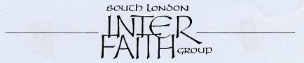
www.southlondoninterfaith.org.uk

EXCURSION TO WOKING MOSQUE
149 Oriental Road, Woking, Surrey, GU22 7BA
www.shahjahanmosque.org.uk

Sunday 31 May 2009, arriving at 2.30pm

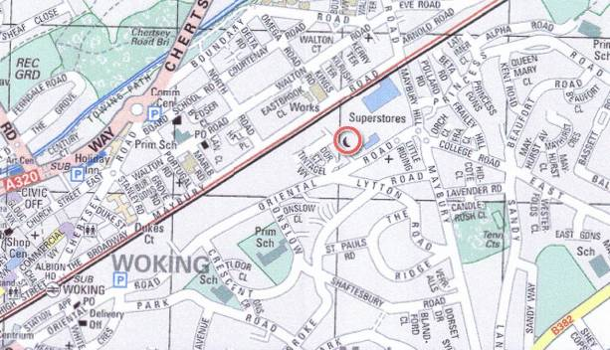

Join us for an excursion just outside the M25 to the historic Shah Jahan Mosque in Woking.

Travel by rail to Woking station. The Mosque is then half a mile away, along Oriental Road.

Or come by car - bring others if you can - there is parking at the Mosque.
(Take A3 from London, then A245, B382, East Hill, College Road, Oriental Road, then follow signs.)

The famous Brookwood Cemetery is only 5 miles (one stop on the train) from the Mosque.

Please let us know if you plan to join us so that we can send you further details.
If you have spaces in your car, please let us know in case others request a lift.

Names please to Alan Gadd at 020 8678 8977 or secretary@southlondoninterfaith.org.uk

