
www.southlondoninterfaith.org.uk

REMEMBRANCE SUNDAY 2008

Multi Faith Act of Remembrance

Firepower Museum, Royal Arsenal, Woolwich, SE18 6ST
www.firepower.org.uk

Sunday 9 November 2008 at 2.45pm

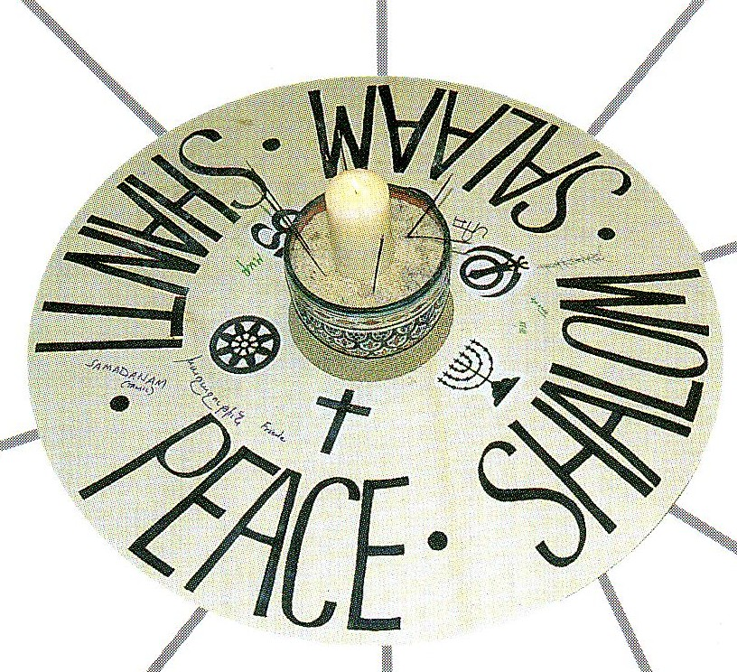

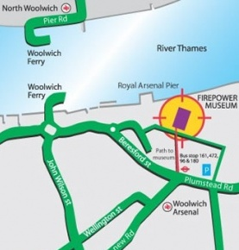

PROGRAMME
Arranged by Greenwich Multi Faith Forum (www.gmff.ik.com) on behalf of Firepower

2.45pm Arrivals

3.00pm Act of Remembrance and Community Declaration

3.10pm Members of faith communities and local organisations light candles
and offer prayers, readings or reflections

3.55pm Concluding ceremony

4pm Refreshments

TRAIN Five minute walk from Woolwich Arsenal station
BUS 472, 161, 96, 180 stop outside Royal Arsenal; 53, 54,422,380 in Woolwich Town Centre.
TUBE Jubilee Line to North Greenwich, then a short bus ride to Woolwich (161, 422, 472
CAR PARK just off Beresford St/Plumstead Rd A206 , east of the roundabout junction A205

Enquiries to Alan Gadd at 020 8678 8977 or secretary@southlondoninterfaith.org.uk

