
www.southlondoninterfaith.org.uk

EXCURSION TO HAVELOCK ROAD GURDWARA, SOUTHALL
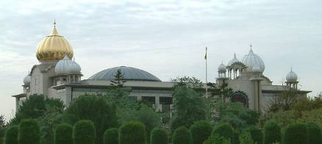
Gurdwara Sri Guru Singh Sabha
Havelock Road, Southall, Middlesex, UB2 4NP
www.sgsss.org

Saturday 17th July 2010, arriving at 3.30pm

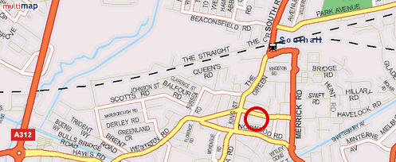

Join us for an excursion to the largest Sikh Gurdwara outside India.

A minibus will leave 24 Holmewood Gardens, SW2 3RS, at 2pm.
Book your seat with Alan Gadd (contact details below).

Or travel by rail to Southall station. The Gurdwara is then about half a mile away.
Bus 482 will take you to ‘The Green’ and then it is 5 minutes walk.

Contact: Alan Gadd at 020 8678 8977 or secretary@southlondoninterfaith.org.uk

