
27 years committed to greater understanding among people of faith

www.southlondonintefaith.org.uk

Annual General Meeting 2008
and Bring and Share Meal
please bring vegetarian food to share with others

Sunday 9th March at 4pm

at the Hyderi Islamic Centre

26 Estreham Road, London SW16 5PQ

The Hyderi Islamic Centre 
in Estreham Road is just 2 minutes walk from the exit from Streatham Common railway station.

We are grateful to the Management Committee for the possibility of holding our AGM at the Hyderi Centre.

Please dress modestly as is usual in such cases.
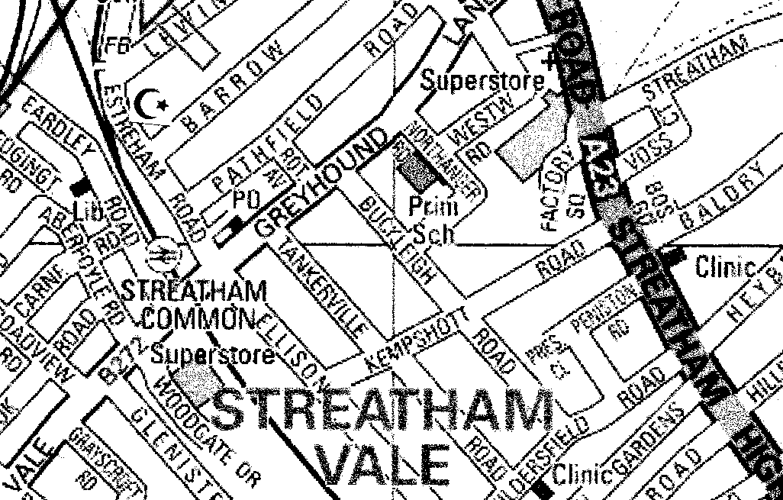

Programme

4pm Business Meeting
Annual Report and Financial Statement
Election of Secretary, Treasurer and Committee
Any Other Business

5pm Books and Resources Information Exchange
You are invited to bring along books, magazines, DVDs or other resources
that you would recommend as useful for inter faith understanding.

6pm Shared Meal

Future dates (provisional)

Saturday 7 June all day, early start - Coach Outing to CANTERBURY

Saturday 12 July all day - Inter Faith Walk in BALHAM and TOOTING

Enquiries to Alan Gadd 020 8678 8977 or secretary@southlondoninterfaith.org.uk

