
26 years committed to greater understanding among people of faith

www.southlondonintefaith.org.uk

Annual General Meeting 2007
and Bring and Share Meal
please bring vegetarian food to share with others

Sunday 18th March at 4pm

at South London Liberal Synagogue
www.southlondon.org
1 Prentis Road, Streatham, London SW16 1QB

The Synagogue in Prentis Road is just a few yards from the junction with Streatham High Road.
Streatham High Road is served by numerous bus routes, but because it is narrow near Prentis Road the bus stops are a short walk further north, just beyond Becmead Avenue
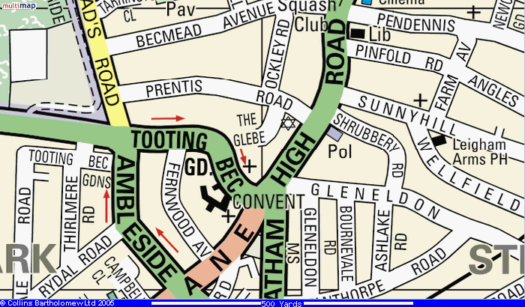

Programme

4pm Business Meeting
Annual Report and Financial Statement
Election of Secretary, Treasurer and Committee
Any Other Business

5pm Interim Project Reports
Improved understanding of South London’s multi-faith situation – Sarah Thorley
Evaluation of different models of inter faith activity – Siriol Davies

6pm Shared Meal

At this year’s AGM we have the opportunity to hear from Sarah and Siriol about the results emerging from their work funded by the grant from the Faith Communities Capacity Building Fund.
Please note in your diaries the date of a Saturday meeting when their final reports will be received.
Saturday 19th May 2007, 11am – 4pm, venue to be announced.
The interim reports at the AGM will get us thinking so that when 19th May comes we shall be able to respond to the reports and discern next steps that we might take as an organization.

Enquiries to Alan Gadd 020 8678 8977 or secretary@southlondoninterfaith.org.uk

