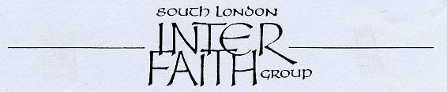
28 years committed to greater understanding among people of faith

www.southlondonintefaith.org.uk

Annual General Meeting 2009
followed by a shared meal
Please bring vegetarian food to share with others.
This event is open to all: do invite your friends to come with you.

Sunday 15th March at 4pm

at St Mary’s Church, West Croydon
(in the Parish Hall)
70 Wellesley Road, CR0 2AR

St Mary’s Church is just a few minutes walk from West Croydon railway, tram and bus stations, near the junction of Station Rd with Wellesley Rd.

Enter the Parish Hall from the yard on the right hand side as you face the Church from Wellesley Road. Then go down some steps. Or enter the back of the hall without steps from the car park.
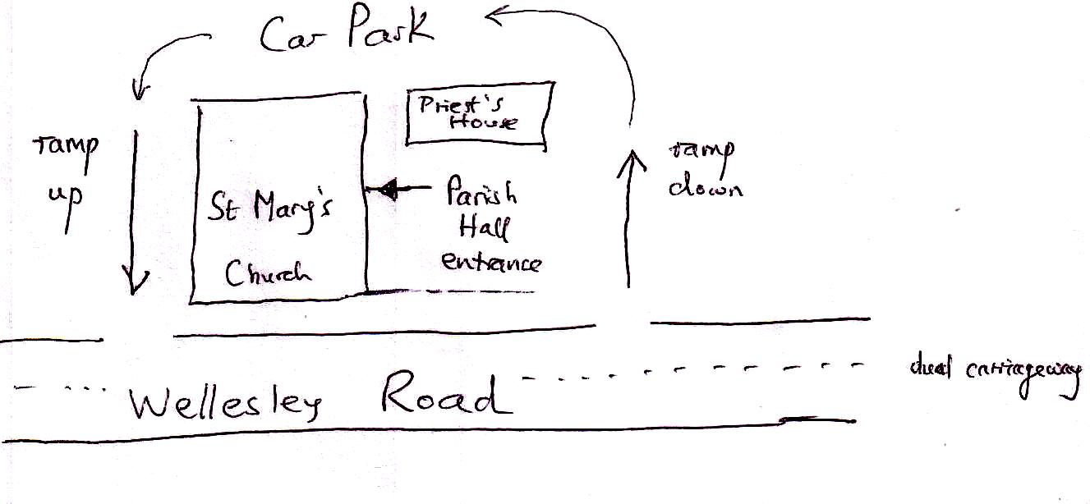
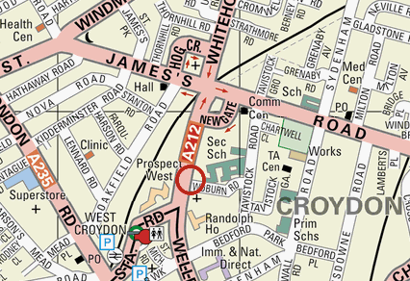

We are grateful to Provost Joseph Collins, the parish priest, for his continuing support to SLIFG.

Programme

4pm Business Meeting
Annual Report and Financial Statement for 2008
Election of Secretary, Treasurer and Committee for 2009/10
Small changes to Constitution; Any Other Business

5pm Welcome to Jain and Zoroastrian friends
Jyotsna Samji and Trusit Shah
Soonu Engineer

6pm Shared Meal

Enquiries to Alan Gadd 020 8678 8977 or secretary@southlondoninterfaith.org.uk

