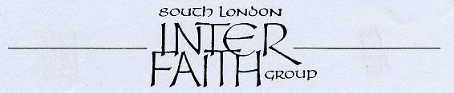
29 years committed to greater understanding among people of faith

www.southlondonintefaith.org.uk

Annual General Meeting 2010
followed by a shared meal
Please bring vegetarian food to share with others.
This event is open to all: do invite your friends to come with you.

Sunday 14th March at 4pm

at Trinity Hospice, Clapham Common
(in the Mulberry Room)
30 Clapham Common North Side, SW4 ORN

Trinity Hospice is located on the North Side of Clapham Common, at the junctions with Long Road and The Chase. It is 5-10 minutes walk from Clapham Common underground station on the Northern Line. Buses 35, 37, 88, 137, 155 and 345 all stop nearby. No parking in the Hospice grounds, but street parking is free on Sundays.

Ask at the reception desk for the SLIFG AGM, taking place in the Mulberry Room.

We are grateful to Anne Hooper, Chief Executive at Trinity Hospice, for her support to SLIFG.
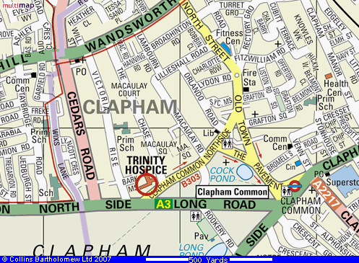

Programme

4pm Business Meeting
Annual Report and Financial Statement for 2009
Election of Secretary, Treasurer and Committee for 2010/11
Any Other Business

5pm A Chaplain’s-Eye View of Trinity Hospice
The Revd Caroline Clarke with Adeela Shabaaz

6pm Bring and Share Meal

Enquiries to Alan Gadd 020 8678 8977 or secretary@southlondoninterfaith.org.uk

