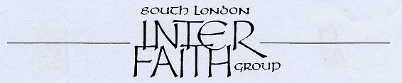
29 years committed to greater understanding among people of faith

www.southlondonintefaith.org.uk

The Streatham Faith Trail

A meeting to mark the launch of a new inter faith resource for Religious Education

Sunday 7th February 2010, 3pm-5pm

at

South London Islamic Centre
8 Mitcham Lane, SW16 6NN

There will also be an opportunity to see around the Islamic Centre

Bus: Streatham is well served by buses to Brixton (for the Tube), Croydon and Kingston.
Routes 57, 133, 201, 319 and 333 stop outside the Islamic Centre in Mitcham Lane.
Routes 50, 109, 118, 159, 249, 250, 255, 315, G1 and P13 stop nearby in Streatham High Road.

Train: There are three stations.
Streatham station (for Thameslink and London Bridge lines) is 5 minutes walk away.
Streatham Hill station (for Clapham Junction and Victoria or Crystal Palace and West Croydon) is 15 minutes walk or a short bus ride.
Streatham Common station (for Victoria or East Croydon) is on the 118 bus route.

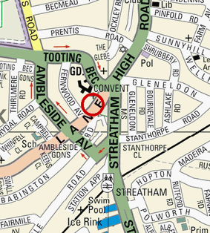

This meeting will provide an introduction to a newly established faith trail in Streatham entitled

Discover your Faith Neighbours

This trail has been designed by Sarah Thorley for the RE trails website set up by the


The meeting will focus particularly on the first three places of worship on the trail:
South London Liberal Synagogue
St Leonard’s Church
South London Islamic Centre
Leaders and worshippers from these places of worship are warmly invited.

Enquiries to Alan Gadd 020 8678 8977 or secretary@southlondoninterfaith.org.uk

