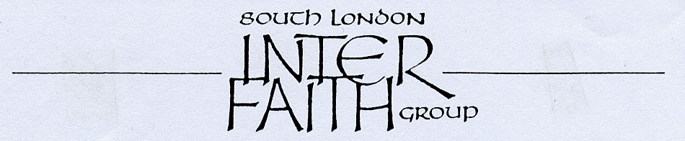
26 years committed to greater understanding among people of faith

Visit to the
Sikh Calderwood Temple

Saturday 27th January at 5pm

1 Calderwood Street
Woolwich
London SE18 6QN



The Temple at 1 Calderwood Street is a
10 minute walk from Woolwich Arsenal Station
(frequent trains from London Bridge).

We are grateful to the President of the Temple, Mr Nirmal Singh Kailey, who will receive us and apprise us regarding the Sikh religion and Sikh culture. After that, food and tea etc. will be available and we are all invited to have food before our departure.

Enquiries to Alan Gadd 020 8678 8977 or holmewood24@surefish.co.uk

