www.southlondoninterfaith.org.uk

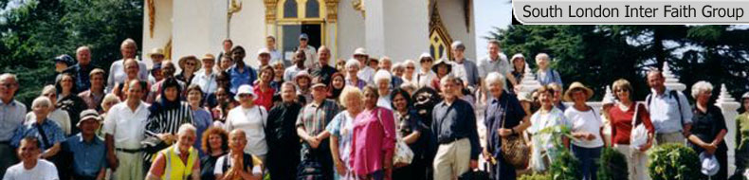
26 years committed to greater understanding among people of faith

South London Inter Faith:
Looking to the Future

Saturday 19th May, 10.30am - 4.30pm

St John’s Church, Waterloo Road, London SE1 8TY

(St John’s is located near the big roundabout with the IMAX Cinema)

A meeting to receive the final reports of the two studies commissioned by South London Inter Faith Group, and funded over the past 12 months by the Faith Communities Capacity Building Fund, and to consider the implications.

10.30 Coffee and collect documents

11.00 Setting the Scene: Brian Pearce

11.15 Improved Understanding of South London’s Multi-Faith Situation:
Sarah Thorley

12.15 Interlude

12.30 Evaluation of Different Models of Inter Faith Activity:
Siriol Davies

13.30 Vegetarian Lunch (provided)

14.30 Panel of Commentators

15.00 Plenary Discussion

16.00 Tea and depart

Enquiries to Alan Gadd 020 8678 8977 or secretary@southlondoninterfaith.org.uk

