

PRAYERS FOR WORLD PEACE

ON REMEMBRANCE SUNDAY

Sunday 11 November 2007 at 4.00pm

KINGSTON MOSQUE ~ 55/57 East Road ~ KT2 6EJ

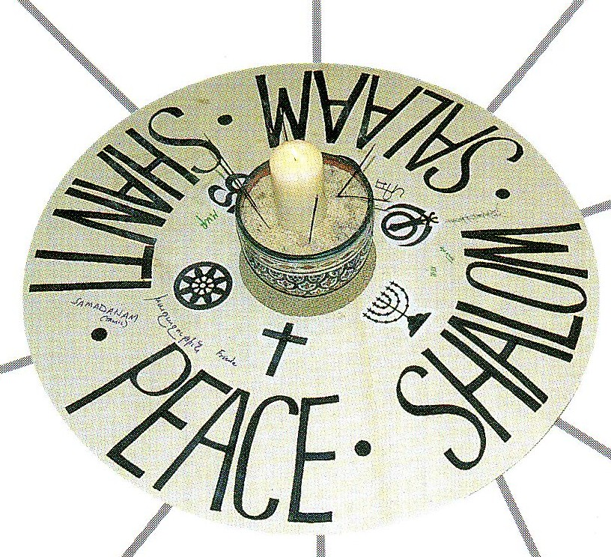

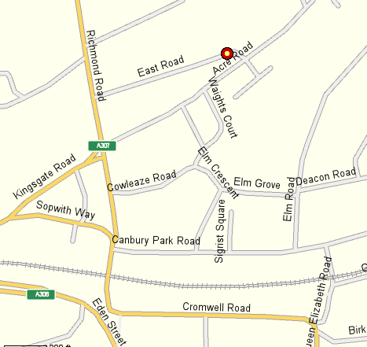

PROPOSED PROGRAMME

4.00pm Arrive in time to observe Maghrib prayers (men and women separately)

Approximately 4.30pm Inter Faith Prayers for Peace (all together)
Invited representatives of several faiths will offer prayers, readings or reflections
then there will be an opportunity for other appropriate contributions
(3 minutes time limit - please give notice in advance)

Approximately 5.30pm Refreshments

(Please notify in advance dietary, disability or special considerations)

Kingston Mosque is located in East Road, a turning off Richmond Road, 5 minutes walk from Kingston Station.
There is unrestricted parking on Sundays in Elm Road and other nearby streets.

Please dress modestly and be ready to remove your shoes on entry. Head scarves will be available for ladies.

Enquiries to Alan Gadd at 020 8678 8977 or secretary@southlondoninterfaith.org.uk

