How to get to Streatham Friends Meeting House

Redlands Way, Roupell Park Estate, Brixton Hill, SW2 3LU

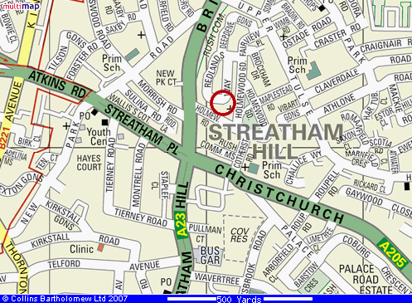

Streatham Friends Meeting House is very near the junction of the A23 (Brixton Hill→Streatham Hill) and the A205 (South Circular Road).

Travel by bus 45, 59, 109, 118, 133, 159, 250 or 333 to the Holmewood Road bus stop (in Brixton Hill, near New Park Court on the map above). From Holmewood Road bus stop there is a footpath leading immediately to Streatham Friends Meeting House, and a large sign is visible from the main road.

Christchurch Road bus stop (just south of the A23/A205 junction) is served by other buses: 57, 137, 201 and 417.

If travelling by tube, go to Brixton on the Victoria Line, then take bus 45, 59, 109, 118, 133, 159, 250 or 333 to Holmewood Road bus stop.

If travelling by rail, go to Streatham Hill station, then take bus 59, 109, 118, 133, 250 or 333 to Holmewood Road bus stop.

Note that Redlands Way is part of the Roupell Park Estate, where car parking is not possible without a permit, and clamping will result. So, if travelling by car, turn into Cotherstone Road (in front of a large church) from the South Circular Road. Park in Holmewood Gardens (free of charge and unrestricted) and walk through to Redlands Way.

