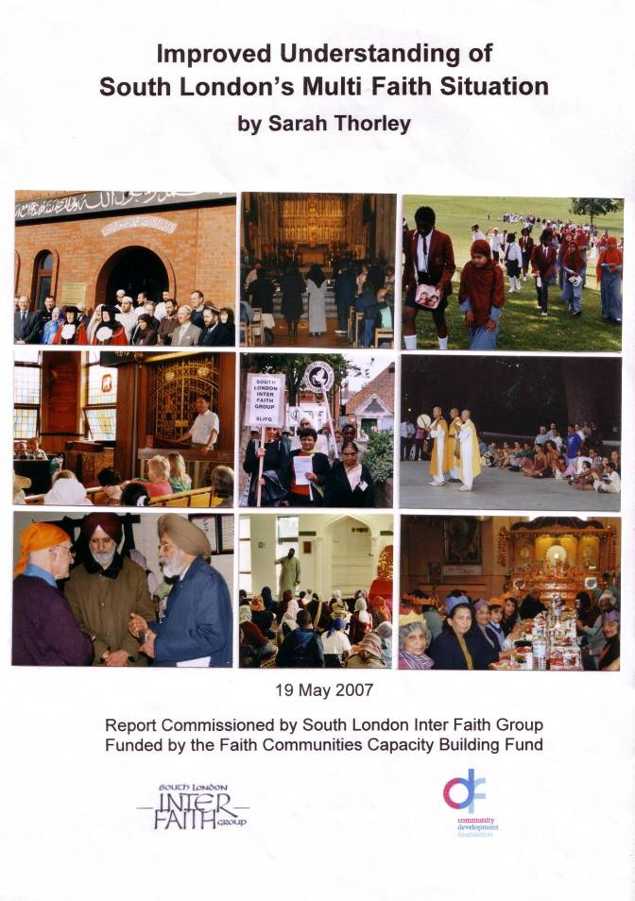
Foreword

During 2005 the Committee of South London Inter Faith Group (SLIFG) was in a reflective mood about the future life of the organisation. Should the pattern of its life as it had developed over its 25 years be maintained more or less unchanged? Or had the time come for a radical reappraisal?

It was thus timely that in the autumn of that year the opportunity was announced to apply for support (for just a 12 month period) from the Faith Communities Capacity Building Fund. The application that SLIFG submitted envisaged a study carried out full-time by a consultant. The grant that was awarded was for a smaller amount, and specified two items in particular from the application, namely:
- An improved understanding of South London’s multi-faith situation;
- An evaluation of different models of inter faith activity.

The Committee of SLIFG decided that the amount of the grant would be sufficient to pay fees to two workers for 50 days each, and for the ancillary task of establishing a website. A Recruitment Panel chose Sarah Thorley and Siriol Davies from among the applicants, and Supervision Groups were established to support them and provide accountability during the project.

This report and its sister volume provide records of the work carried out, and include some pointers from the authors as to the questions to be considered as South London Inter Faith Group looks to the future. Taken together with the responses at the launch meeting on 19 May 2007, I believe they can fulfil their purpose in enabling informed decisions to be taken that will assist South London Inter Faith Group to play a constructive role in the changing inter faith scene.

Alan Gadd
Secretary
April 2007

Reprinted September 2008
1 | 2 | 3
4 | 5 | 6
7 | 8 | 9

Photographs on front cover
1. Photo call before the Civic Service and lunch at Kingston Mosque February 2007
(at which about 30 non-Muslim visitors were present).
2. Remembrance Day 2006 – SLIFG event at Southwark Anglican Cathedral –
Meditation for Peace with readings and reflections from all faiths.
3. Year 5 pupils from Holy Trinity and Gatton Muslim schools meet for a picnic in
Brockwell Park, as one of their regular termly exchanges.
4. SLIFG Inter Faith Walk 2006 – visiting Catford (Orthodox) Synagogue (and a
Reform synagogue, Anglican and Roman Catholic churches and an Islamic Centre).
5. In 2004 SLIFG collaborated with Greenwich Multi Faith Forum for an Inter Faith
Walk through Plumstead.
6. Nagasaki Remembrance Day in Battersea Park – the annual ceremony at the
Nipponzan Myohji Buddhist Peace Pagoda – led by Bikkhu Nagase.
7. Welcome and hospitality for the members of SLIFG at the Calderwood Street
Sikh Gurdwara in Woolwich in January 2007.
8. Primary school children learning about Islam at Gatton Mosque, Tooting.
9. Christmas lunch at the Caribbean Hindu Temple in Brixton – neighbours invited!
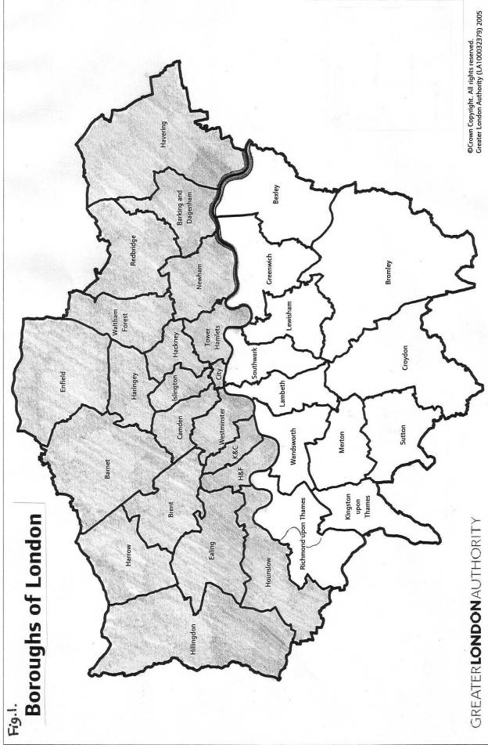
SOUTH LONDON INTER FAITH GROUP
LOOKING TO THE FUTURE
SOUTH LONDON’S MULTI FAITH SITUATION

19 MAY 2007

TEN QUESTIONS BEHIND THE FOLLOWING REPORT

How can a strategy for consistent inter faith networking
be established south London–wide?

How can we collaborate and share skills and experience with
- Local Authority personnel?
- multi faith chaplaincies?
- SACREs (see page 4)?

How do we respond in our local situations, when there is a national or international political crisis with a religious dimension?

How can our programme benefit:
- those who are seeking spiritual enrichment?
- enquirers wanting education and resources?
- those needing confidence to meet people of other religions?

How do we inspire a greater number of our own members
to become more actively involved?

How do we reach those people who are not already ‘converted’
to the inter faith cause?

How can we engage more young people from all the faith groups?

How can we encourage a wide variety of people
to make use of our new website forum?

How can we engage more beneficially with local inter faith groups?

Can/should the SLIFG be an ‘umbrella’ resource for south London’s regional organisations and faith communities in
- Sharing knowledge and experience?
- Facilitating communication?

CONTENTS

1. The brief p.4
2. The method p.4
3. The 12 Boroughs p.5
4. Places of worship p.10
5. Inter faith groups p.14
6. Observations p.15
7. The way ahead for the SLIFG . . . p.17
8. References/bibliography p.22
9. Appendices:
1. questionnaire sent to SLIFG members p.22
2. list of addresses of places of worship in south London p.23
3. Lambeth map p.25
4. list of inter faith groups in south London p.26
5. borough by borough summary of findings p.28
6. article by Rabbi Jonathan Romain p.33

SLIFG = South London Inter Faith Group GLA = Greater London Authority
GOL = Government Office for London LA = Local Authority
FLC = Faith Link Contact RE = Religious Education
SACRE = Standing Advisory Council for Religious Education
FCCBF = Faith Communities Capacity Building Fund

1. The brief
In February 2006, the committee of the South London Inter Faith Group
(SLIFG) heard that they had been successful in attracting £18,100 from the
Faith Communities Capacity Building Fund.
By May 2006, I had been recruited to work for one day a week for one year,
to ‘gain an improved understanding of multi faith south London’, using part
of the grant. Siriol Davies would be exploring different models of inter faith activity outside of south London. Alan Gadd (Secretary of SLIFG) would commission Bhupinder Singh to make a website for the SLIFG. Between us,
we would use the money to gain a better overview of the multi faith situation in south London, we’d have new ideas as to how our group might develop to benefit the cause of inter faith engagement in south London and more efficient ways
to communicate and publicise our activities. What follows is a report, primarily
for the members of the SLIFG, of my year’s work.

2 .The method
A supervision group of four of our committee members were designated to meet with me during the year to monitor my progress and discuss what next. I have found that very helpful, especially as it was such a wide-open brief. Where should
I start? What and where is ‘south London’? Where does it end? And if I achieve
a better understanding, how is that to benefit the SLIFG?

I sent out a questionnaire to all 250 of our members (appendix 1). From the 27 responses I received, there were some helpful contacts which I followed up and it was also interesting to discover related interests that many of our members have (I’ll come back to this in my recommendations).
Next I needed some boundaries. I contacted City Hall and was helpfully sent a map of the London Boroughs (see p.2). Now I literally had the boundaries I needed to give me some structure. I decided to tackle my task borough by borough. There are twelve boroughs in south London, south of the River.
Through this process, I would:
  - endeavour to find out what the local council in each borough was doing with regard to the faith communities in their area
  - try to identify the locations of any places of worship, particularly those other than Christian that I did not already know and make contact with them
  - search out local inter faith groups and initiatives and try and attend one of their planning meetings and at least one of their events

During the year, I’ve attended meetings and events all over south London - in architecturally fine town halls, in smart civic suites, in people’s living rooms and kitchens, in crowded community centres, in a mental health centre, in synagogues, gurdwaras, temples, churches and mosques. I’ve gathered a great deal of information about organisations and events, places of worship and multi faith groups, population statistics and the workings of local government. I’ve spoken with inter faith group convenors, council officers, imams, priests and rabbis, borough deans (see page 8) and policemen, map makers and SACRE members.
Early on, the Revd Stephen Saxby, convenor of the London Boroughs Faiths Network, gave me the contact details of many crucial grass-roots ‘inter faith’ people in south London, most of whom have turned out to be invaluable sources
of information.

In November last year, I gave two presentations on ‘work in progress’.
One was at the large annual multi faith gathering of local people in Lambeth Town Hall, at which I ran a workshop about the work of the SLIFG and how the FCCBF grant was being deployed.
The second was a brief talk about the work of inter faith groups in south London, at St Ethelburga’s Centre for Peace and Reconciliation in the City. The occasion was the launch of the feasibility study for the proposed new Faith Forum for London.

- The twelve boroughs
Religious diversity
You will need only a glance at the map on page 2, to guess how different the twelve boroughs of south London might be. For example, Bromley is the largest in area and Lambeth the smallest. Apart from churches, Bromley has one synagogue and one mosque and Lambeth has two Buddhist centres, two Hindu temples, six Islamic centres and two synagogues. (Of course this does not mean there are no Hindus or Buddhists living in Bromley.)
I have collected a good deal of information about religious presence and inter faith activity in each borough, but it is not complete enough to analyse it, except anecdotally, for this report.

However, I also received, from City Hall, a fascinating GLA document: ‘Religious Diversity Indices’ (2005/6). It is based on the 2001 Census which contained a voluntary question on religious affiliation, for the first time since 1851. It looks at the population of London in terms of religious diversity using ‘Simpson’s Index’, which takes account of both the number of different faith groups and the sizes of these distinct groups relative to each other. Fig.2 shows the population numbers for the different religions in England and Wales as compared with London.

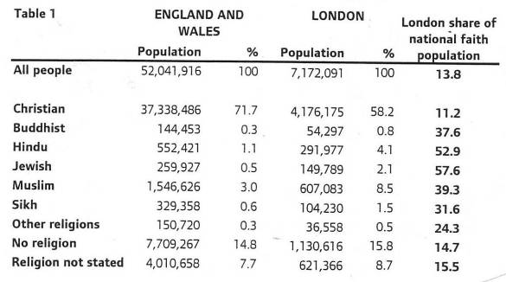
Fig 2 . Copyright: Office for National Statistics, 2001 Census, KS06

Another chart reveals that 9 out of south London’s 12 boroughs fall within the top 50 most religiously diverse local authorities in the country. (Of north London’s
22 boroughs, 19 fall into that top 50.)
Something else very interesting which emerges from the religious diversity maps
of the different wards, is that there are no south London wards in the top 50
(40 of the 50 top wards are in north London.) This would seem to indicate that minority faith communities in south London are much less densely gathered,
less concentrated; that they are dispersed more evenly within the population.
This I would suggest, has implications for inter faith relationships: does it mean,
as a generalisation, that the religious minority groups are more integrated and confident and therefore able and willing to get involved with inter faith relationships? OR would the relative integration and confidence mean that they
do not feel the need or urgency to do so? And the same questions could be asked
of the rest of the local population – are there few perceived religious ‘problems’ because we are all living together relatively happily; there are no threatening neighbouring religious ‘enclaves’? Which could mean it’s easier and more relaxed getting on with our other faith neighbour OR which could mean there is no need
or urgency to do inter faith relationship work? [Of course this is simplistic. For further reading about the significance of the context in which inter faith dialogue takes place, read Andrew Wingate’s book especially p.15 – see bibliography].
Incidentally, the four most religiously diverse wards in south London fall within the boroughs of Wandsworth, Croydon, Merton and Greenwich. Sutton is singled out as one of the least religiously diverse boroughs in the country and it borders with Croydon!

Local council Faith Link Contacts
Hyacinth Parsons at GOL (Government Office for London) sent me a list of the ‘Faith Link Contacts’ (FLC) in each borough. I learned that every London Council has been required to appoint a designated ‘Faith Link Contact’ person (FLC) to work with the diverse faith communities in their borough. I now had a list with contact details for these twelve key personnel. An FLC may be located in one of a variety of local government departments such as: Community Cohesion, Equality and Diversity, Human Resources, Social Inclusion and Justice, Faith and Social Action, Faith and Equality. It appears that each FLC’s brief/job description, workload and funding, commitment and time allocation to the ‘Faith’ element, varies considerably from borough to borough.

The GOL runs a programme of bi-monthly meetings or courses which may be attended by the Faith Link Contacts. These may be guidance about faith issues, delivery of services associated with equality and community cohesion, sharing good practice or planning for a major emergency (terrorist or epidemic).
These meetings may be followed up by action in the borough – but every council
is autonomous and some give more priority to a faith agenda than others.

The FLC’s role may include any or all of the following. He or she will:
- be in contact with the local faith leaders and disseminate relevant information;
- know where the faith communities are located and keep an up-to-date directory
of places of worship in the borough;
- be in contact and share information with any local inter faith group;
- liaise with the SACRE and other relevant council departments, facilitating good
communication between the Council and faith communities;
- collaborate with faith leaders to convene regular ‘Faith Forum’ meetings (at
which organisations such as the police and other relevant social services and
voluntary organisations like Age Concern and Street Pastors may have input),
ensuring faith groups are represented in council decision making processes;
- supervise allocation of funds for faith community projects;
- produce a regular newsletter with information about local religious activities
and any council policies relevant to faith communities;
- organise annual community events such as a Peace Week, Civic Services,
Holocaust Memorial Day, networking meetings and so on.

Multi Faith Forums
Eight of our twelve boroughs currently have active ‘Multi Faith Forums’ (with
a variety of names - ‘Faiths Together in . . .’ or ‘Faith & Belief Forum’ or ‘Faith Steering Group’ or ‘Multi Faith Network’ – see appendix 3); some are much more active than others. Some of these are quite new developments that have come into being or been ‘re-activated’ as a response to the bombings of July 2005.
I have attended ‘Faith Forum’ meetings and met the Faith Link Contacts of six of the twelve boroughs and spoken on the telephone at length, with five of the others.
They do operate very differently from borough to borough.

- Some of the ‘Faith Forums’ are convened and serviced by council staff in conjunction with representatives of local faith communities (and sometimes inter faith groups). These may meet quarterly or bi-monthly mainly as a consultation and information sharing forum but also possibly to plan together events such as Civic Services and Peace Weeks.
- With others, the initiative comes much more from the faith leaders and/or lay representatives and the Council may have minimal regular involvement – in at least one case it just provides a free venue for meetings. The agenda at the meetings and events is likely to be more inter faith relations based and learning about religious beliefs and practices, rather than project based.
- In some boroughs it is more likely to be a question of the Multi Faith Group inviting council members to attend their meeting when relevant.

There are also meetings three or four times a year, between leaders of the Council and ‘Borough Deans’, to discuss relevant issues. Borough Deans are leaders of
the Christian denominations. There is currently discussion in some boroughs about whether these meetings should be widened to include leaders of other faiths.

Also, of course, there are independent, voluntary local inter faith groups – see section 5 - which may have little or no contact with the local council. In some places there is an overlap, where some people are involved in both the ‘Council’ group and the independent inter faith group. Interaction and consultation between the council and local inter faith groups varies from borough to borough.

SACREs
Every Local Authority has its own SACRE. Its role is to determine the character
of religious education in the local schools. This includes collective worship and
an ‘Agreed Syllabus for RE’ and RE in-service training for teachers.
It is immediately obvious that to have representatives of the different religions
on the SACRE is extremely important. The way in which religion is taught to our children should be of key importance to all of us interested in inter faith harmony.
I think that in most boroughs, improved communication between SACREs and FLCs and inter faith groups would be beneficial. Each of these elements may be
in touch with individual faith communities and often requests (eg for visits or speakers) are duplicated – to the puzzlement and sometimes annoyance of faith leaders.
It is encouraging to read in the most recent national SACRE newsletter that:
a) there are plans to strengthen the partnerships between SACREs and Local Authorities (FLCs and other relevant council officers) and
b) a pilot project has been taking place – partly in south London - to recruit
and train potential SACRE members from the faith communities.

Brief mention here of single faith schools. There are of course many Anglican
and Roman Catholic schools and I know of five Muslim schools (two of which
have recently become state funded) in south London. There may well be others.
There is a termly exchange which has been thriving for four years, between an Anglican school and one of the Muslim schools. Hopefully other similar inter faith school exchanges will be initiated.

Communicating . . . . . .
You may be wondering what has all this got to do with the SLIFG. Well it has become clear to me that COMMUNICATION is one of the most critical questions.
How good is the communication between us all? Between the SLIFG and other local inter faith groups, between the council inter faith personnel, the council SACRE and SLIFG; between SLIFG, the council and faith communities?

First of all, do we know about each other? Do we support each other? Trust each other? Do we share information? Share best practice? Collaborate so that eg dates don’t clash? Do we consult and co-operate? Not compete and duplicate?

In the diagram opposite, I have started to draw in dotted lines to indicate further cross-communication. You might like to continue this process (it will look rather like a spider web!)

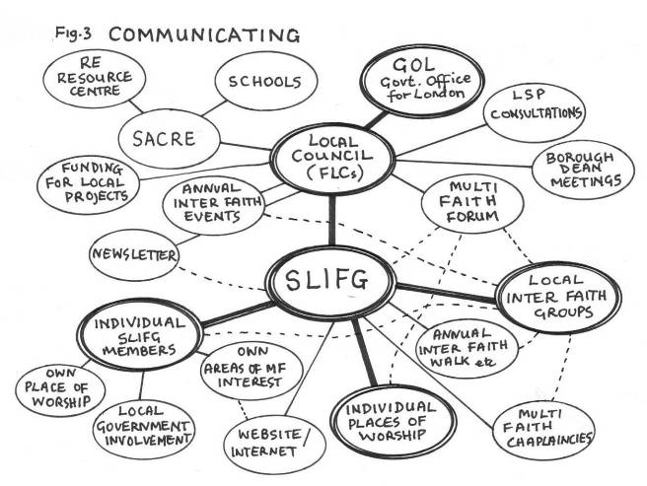

Constructive communication varies greatly from district to district. There are
some excellent things happening in some places and almost nothing happening
in others. It seems to me that inspiration and good practice needs to be shared much more. Just a few examples:

- In one borough (where there is only one place of worship that is not Christian), early on in my work, I discovered a flourishing multi faith mental health chaplaincy, co-ordinated by a Muslim woman AND a small but thriving inter faith group chaired by a Sikh, but the groups didn’t know about each other. The council Faith Link Contact did not know about the chaplaincy or the inter faith group. Things have moved on during the year and hopefully they are now all on each other’s mailing lists and planning a co-ordinated ‘inter faith’ stall at their annual summer community festival.

- Another borough sent me a draft of an information booklet about the different religions, to be given to all their council staff – a very good idea, but it was full of serious errors and has now been shelved. It’s worth noting that Southwark Council has produced an excellent booklet about the religions which could perhaps be adapted and used by other boroughs.

- In Lambeth, the Faith Steering Group is struggling to work out its precise role – it could well learn from sitting in on a Kingston Multi Faith Forum meeting. However, the Lambeth FLC produces ‘Faith in Lambeth’, one of the best quarterly newsletters that I’ve seen anywhere in south London, which other boroughs might be inspired by.
- Probably the most vibrant grass-roots meeting I went to, was a Wandsworth Multi Faith Network meeting. Over 40 people representing all the major faiths gathered in a crowded upper room in Tooting. Some really exciting and innovative plans were debated – including a particular project about sharing assets (eg bartering skills for premises). But apparently the Network funding (from the Office for Neighbourhood Renewal) is not to be renewed.

- In one borough, the Faith Link Contact, who sounded keen to get things moving, did not seem to know where to start, didn’t have the knowledge
or the confidence. I was able to put her in touch with the three ‘inter faith’
people I know of in the borough. In another borough the Faith Link Contact
didn’t know about the inter faith group which has been active in the
borough for some time and meeting regularly in the Civic Suite! Neither had
she visited any of the local places of worship that was not Christian.

- In one borough, an excellent sixth Form Conference was organised. The SACRE collaborated with the Multi Faith Forum and the key local faith leaders were on the Question and Answer panel. It was very well prepared and executed. Well attended and the young people got a lot from it and want more. Couldn’t this piece of good practice be replicated in other boroughs?

- NB. Very few of the FLCs had heard of the South London Inter Faith Group!

It’s not that we all want to go to everything. Nor do we want everything to be the same in every place. We certainly don’t and we all have our different interests and different priorities but surely it’s important to be aware of what else is going on. Communicating with each other and sharing best practice seems to me to be essential.

4. Places of worship
I had originally thought I would work towards producing a map of south London with all the places of worship located and listed. But it rapidly became clear that this was not going to be possible in the time, especially to include the numerous Christian places of worship. So I made the decision to concentrate on the places other than Christian. I obtained from each borough, a directory of its places of worship (these of course do list all the variety of Christian denominations) but
it must be said that some of them are more accurate and up-to-date than others.

It is not straightforward - multi faith presence is very complex: it may involve sharing buildings; there may be cultural, ethnic and language aspects within each religion, which have implications for gathered worship; there is a great variety
of Christian churches, many of African and Caribbean origin which operate
independently; there are branches of religions not recognised by the ‘mainstream’; there are faith communities with no local place of worship; there may be distance travelling to places of worship. Some meetings for worship take place in partially converted houses; new places for worship are coming into existence all the time and some faith communities are having great difficulty finding acceptable sites for new buildings. There is the controversial issue of different faiths being able to use the same worship space and indeed that of redundant churches being purchased by other faith communities. There is the ongoing struggle for many faith communities to fund and maintain buildings, to comply with expensive health
and safety regulations and pay prohibitive insurance premiums.

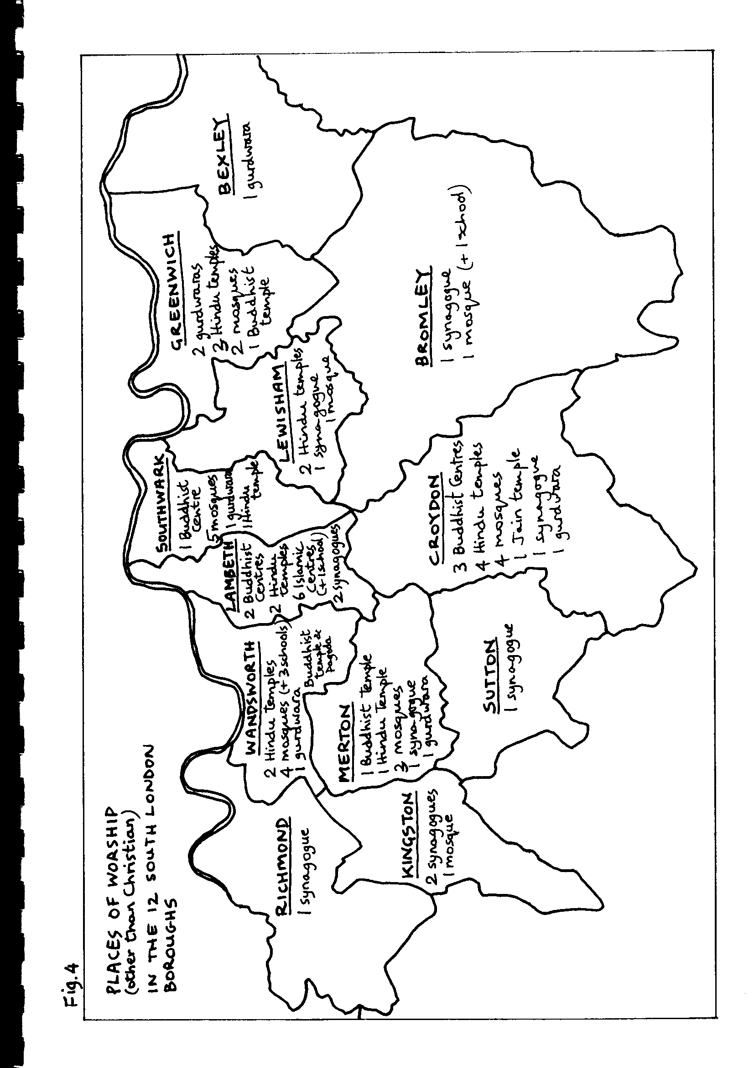

Fig.4 is a map showing you the places of worship – other than Christian - that
I have located in each borough. Please inform me if you know of any that I have missed. Appendix 2 lists the addresses of these places of worship. (Anglican churches and some others are marked with a cross on the London A to Z map.)
Appendix 3 is a draft map of places of worship in the Borough of Lambeth, designed by Lambeth cartographer Stephen Marsh. The final version will have
the Christian places of worship marked on it.

I have identified 64 places of worship and visited 47 of them. Many of these
I already knew and have contacts with – partly through the ten Inter Faith
Walks that the SLIFG has organised since 1997 (see fig. 5).
The SLIFG has invariably been most warmly received at so many of the places listed. I’d like to note just a few places which have been particularly supportive over the years: Bikkhu Nagase at the Nipponzan Myohji Buddhist Peace Pagoda and Temple in Battersea Park deserves a very special mention; he has so often led the SLIFG Inter Faith Walks with his distinctive drumming – and indeed hosts many inter faith events at the Pagoda. Appreciation is also due especially to the people of the Caribbean Hindu Temple in Upper Tulse Hill, the Hyderi Islamic Centre and the Liberal and the Orthodox Synagogues in Streatham, the Stockwell Green and the Tooting Islamic Centres and the Sikh Khalsa Centre in Tooting.
And of course many churches too – St Matthews Brixton and All Saints Battersea come to mind. And not to forget the Baha’is, who do not have specific buildings
for worship in south London, but are involved in many inter faith enterprises.

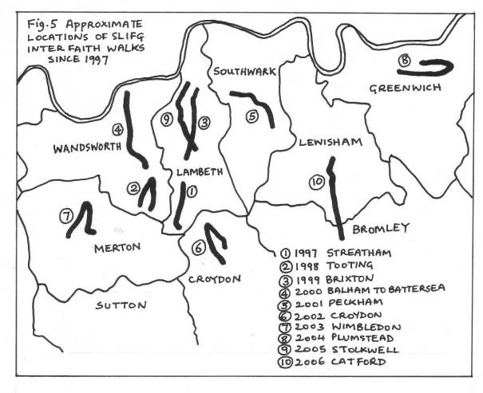
Local surveys
Two very recent interesting and detailed local surveys deserve mention.
Firstly, a very thorough survey of the Borough of Croydon, identifying all the places of worship and who uses them and for what purposes, that was completed by Penny Smith-Orr in 2006. Similar surveys of all the other boroughs would be invaluable, resulting in a comprehensive overview of places of worship in south London.
Another fascinating survey undertaken by Siriol Davies for the Anglican Diocese of Southwark in 2006, identifies faith and ethnic communities living in the Borough of Southwark and how they relate to their local Anglican parishes. She tells me that she will soon be starting a similar survey of the Borough of Lewisham (this is of course from a Christian perspective).

Informal conversations
At a more personal level, I’ve had some fascinating conversations with members
of faith communities about inter faith visits to places of worship - in particular with two Muslim women, three Muslim men, a Sikh woman and a Sikh man,
a Jew and a Hindu and various Christian and ‘secular’ friends.

A few personal random observations, generalisations.
- We all seem to be struggling to energise members of our own place of worship
to take an interest in and get engaged in inter faith dialogue and activity.
- For most of us, keeping our young people involved is a great challenge, although
many of them have more knowledge of other faiths, through religious education
at school, than their parents.
- Primary school children are fascinated by visits to places of worship (so long
as they don’t have to listen for too long to a speaker – they love all the visual
differences and what people do).
- Whereas many good inter faith initiatives are driven by Christians, they find it
hard to mobilise members of their own congregations; a few of whom may be
interested to visit another ‘exotic’ place of worship, but there is much apathy
(Or apprehension of the unknown? Or concern that they are compromising their
own beliefs?).
- Christians don’t often invite people of other religions to visit their churches –
I’ve several times heard a Sikh or Muslim or a Hindu who may have lived in the
UK for years, say they’ve never been into a church, never been invited, not sure
if they’d be welcome or if someone would try and convert them. However, I have
a Hindu friend who says when he first came to the UK in the 50s, there were no
Hindu temples, so he went quite comfortably to a church for years and still feels
quite at home in a church.
- I’ve heard other Christians say they find it difficult to persuade people of other
faiths to come to their church or to commit themselves to inter faith meetings.
And that they’ve sometimes felt let down by speakers failing to turn up.
Somewhere here there is a failure in communication.
- My impression is that since 9/11 more of the Islamic Centres are being pro-active
and opening their doors to groups of other faiths, especially their neighbours in
the local community and that is being appreciated.
- One Muslim leader says it takes all his energy to unify the different factions
within his mosque and to try and keep their young people engaged.
- Hospitality is not a strong point in churches (although it is in biblical teaching) –
a cup of tea or coffee and dry biscuit which you might have to pay for! In a temple
or gurdwara and often in a mosque you will rarely leave without being generously
fed!
- A rabbi was delighted to receive a good turn-out of members of other faiths at
an event at his synagogue about the history of the Jewish presence in south
London. It also gladdened his heart that members of the Orthodox, Reform and
Liberal traditions of Judaism were all present together in this Liberal synagogue.
An inter faith event can also become a place of constructive meeting for members
of different branches of the same faith who otherwise may not communicate.
(See Jonathan Romain’s article, appendix 6).
- People from the same nation, where there may be strife, meet at inter faith
events here, across religious divides. For example on July 14th the SLIFG annual
Walk will visit the Nigerian mosque in Southwark and walk from there to
St Peter’s Church where there are many Nigerian Christians – there is a plan
to provide a Nigerian meal for the walkers, at St Peter’s. We hope that both
Nigerian Muslims and Christians will join the walk. The ethnic diversity of inter
faith events can also enhance inter racial relationships.
- I read recently in The Muslim News, a plea for Sunni and Shi’a Muslims here in
the UK to make a huge effort not to let the sectarian violence in Iraq infect Sunni
and Shi’a relationships here. Currently there is a Sunni and a Shi’a on the SLIFG
committee.

5. Inter faith groups
Appendix 4 lists the twenty-four inter faith/multi faith groups/forums/networks in south London with which I have been in touch. Please inform me if you know of any others.
The SLIFG is the ‘oldest’ (still existing) inter faith group in south London by
twelve years, having been founded in 1981. Next comes the Wimbledon group and LAMAG in Lambeth in 1993, followed by the Greenwich group in 1995. Most of the others have come into existence since 2002. You can find out more of the history and activity of the SLIFG on their new website at: www.southlondoninterfaith.org.uk

Many of the SLIFG members are active in their local groups. There is wide variation in how these eighteen groups operate and in what their main aims are. In terms of operation, some are small informal, independent local inter faith groups. Others are more formal with constitutions and mailing lists and subscriptions. There is a branch of the national Three Faiths Forum (Christians, Jews and Muslims) and two branches of the national CCJ (Council for Christians and Jews). There are groups of faith representatives who liaise with their local council LSP (Local Strategic Partnership) and some of the more formalised local inter faith groups work as a group with the local council and a proportion of their meetings are joint meetings (eg in Kingston and Croydon).

Aims range from:
- to be better educated about religions;
- for personal spiritual enrichment – theology, prayer, meditation;
- to work on a collaborative social action agenda, sharing best practice;
- to work with council faith forums on policy issues relating to faith concerns;
- to debate and address current social/political/religious issues;
- to counteract national and global crises which can threaten local peaceful
co-existence;
- just to be social and make friends with people of other faiths, overcoming ignorance, fear and stereotyping.

I have been privileged to attend one or more meetings and events of all but four
of these groups. One or two are struggling – from lack of new leaders, absence
of younger people, lack of commitment from their own faith communities, feelings of isolation, speakers not turning up or disappointing numbers at events planned.
I’ve heard of two that have fizzled out.
However, new ones are starting up and flourishing, the most recent being FATE
in the Elephant and Castle area of Southwark. FATE (Faith Around The Elephant) kicked off last year. It was inspired originally from exchange visits between a group from Southwark Anglican Cathedral and the Hyderi Islamic Centre in Streatham. These prompted the Southwark group to find out more about the multi faith scene in their own area and FATE was born. The first meetings, for friendship and better understanding of each other’s religions, have centred around discussions of relevant spiritual and social topics and shared food.
The well established Stockwell Faith Forum, chaired by Catriona Robertson, last year became the CSFF (Clapham and Stockwell Faith Forum) and as from this year now has funding to employ Hannah Barker as the full time co-ordinator. They are developing a very cutting edge and innovative programme including a Women’s Art Group, Round Table discussions on topical issues (eg wearing the niqab) and
a teenage football club and an excellent website.

Chaplaincies
We should not forget the contribution of multi faith chaplaincies in hospitals, prisons, colleges, universities, industry and other institutions. Contact should be made with these chaplaincies as, although they have their own specific agendas, there is much that we could learn from each other: they are really at the cutting edge and should be recognised as making significant contributions to the inter faith scene. I must mention the Oxleas multi faith mental health chaplaincy which covers the boroughs of Bexley, Bromley and Greenwich. Their co-ordinator, Qaisra Khan, has been a source of endless information and inspiration to me and we have had many conversations and even been together to York for a Christians and Muslims ‘Prayer as Meeting’ weekend conference.

6. Observations
Central government has community cohesion high on its agenda and has recognised that faith communities have invaluable knowledge and experience and contacts right at the grass roots of society; that they are often engaged with the most marginalised members of society. Welcome funding has been made available. But I’ve heard of at least two instances where some funding has apparently not got through to the Faith Forum. Could there be more co-ordination between boroughs?

Local government is charged with tapping into the faith communities’ knowledge and experience in order to learn from it and for mutual support, to consult when appropriate for policy making and to administer funding to support community projects. The council Faith Forum initiatives are to be welcomed. However I think, from a number of conversations I’ve had, that there is a question mark about how well co-ordinated many of the local government initiatives are and recruitment of personnel is somewhat random, some people being in post without the necessary knowledge and resources or clarity of role.

Places of worship are springing up around south London (one of the reasons it’s hard to keep an up-to-date directory). It’s often difficult for faith communities to find acceptable premises or sites for new buildings. Residents say ‘not in my back yard’. I came across a Muslim group who have been looking for a while in Sutton and the Vietnamese Buddhist community who meet at the Linh Son Temple in Beulah Hill have been threatened with eviction because their numbers cause parking problems. Ever more parking restrictions have become a major difficulty for worshippers, on Sundays as well as weekdays (I heard that even a hearse got
a penalty ticket outside a church!) The answers are not clear cut and, as ever, communication and consultation is key.
Premises can be a blessing and a burden! Maintenance of premises, as mentioned before, is often an ongoing financial burden for faith communities, not easily resolved. How can available space be made accessible to those who badly need it? For example a Hindu temple has a good space it could rent, which could be well used by local groups, but they cannot afford a full time caretaker, nor the cost of complying with health and safety regulations and of the necessary insurance cover. So most of the week it stands empty even though rental revenue would be a godsend. I know of several similar instances. What can be done? For example, could the council arrange some kind of corporate insurance for places of worship which would bring down the premiums?
Overall it is quite remarkable and inspiring what is achieved by so many of the faith communities – in terms of sacrificial financial giving, in terms of voluntary effort to provide spiritual and social sanctuary and also outreach at the very grass roots of society – sometimes in the face of a sceptical and even hostile secular and materialist environment. It’s probably true that because many of the faith communities are absorbed with their own survival, they do not have the energy
(or inspiration or motivation?) to make inter faith engagement a priority.

Inter faith groups around south London are taking new initiatives and treading new territory. And for those who feel it’s an uphill struggle, I would say don’t give up – though tactics might need to change. I remember when I was feeling despondent once about low turn-outs at meetings, a wise person said to me
“You never know what seeds are being sown – each person there might influence another ten people that you won’t know about!”
And numbers is not everything. One of the best meetings I went to was the
Bexley Multi Faith Forum’s meeting on a Saturday afternoon in the hall belonging to a gurdwara, on the topic of prayer. There were 18 of us. A Christian, a Hindu,
a Muslim and a Sikh – all members of the Forum – spoke about what prayer meant in her tradition (they were all women speakers). The personal sincerity of each speaker was palpable and a very meaningful discussion followed.
Every effort is worth it; when it really matters it does make a difference.
Three examples:

- Stockwell – July 7th 2005, the day of the London bombings. Our annual Inter Faith Walk was due to take place two days later. I had several phone calls asking if the Walk would go ahead. Yes absolutely I said. And indeed
it did seem like a really important act of witness to be out there together on
the streets of Brixton and Stockwell that day. At the Stockwell Green
Mosque, because many of us already knew each other – we’d had meetings
there before – we were able to speak openly and freely and express feelings
of fear and anxiety, support and solidarity. Later at the Peace Tent in
Larkhall Park, we held a large circular rope ‘peace mala’ and affirmed our
determination not to let events outside, beyond our control, divide our local
communities.

- You may remember that a year or so ago there was much speculation about a regional casino being located in The O2 (the Dome). It was said, controversially, that it would bring regeneration and jobs to the Greenwich Peninsula and surrounding area. The Greenwich Peninsula Chaplaincy, which organizes a multifaith team of chaplains on the construction site inside the O2, found itself in the media spotlight; and because a year earlier it had held a consultation with the Greenwich Multi Faith Forum and with others on the different faiths’ attitudes to gambling, chaplains and trustees were able to speak with authority on behalf of those faith communities.
An example of relationships of trust having been built up and of how the
groundwork paid off when an issue blew up in the media.

- In November last year, the façade of the South London Liberal Synagogue was desecrated with very distressing images. Rabbi James Baaden was understandably very disturbed by this and emailed his colleagues and friends on the inter faith network in Lambeth and beyond. He and his congregation found considerable comfort in the supportive response
they received over the next few days from their friends of other faiths.
In describing what had happened, in the synagogue newsletter, the Rabbi
ended ‘So we had a bad moment – and it passed – and we were made aware
of all our friends around us.’ Again, relationships built up beforehand can
count for so much when a crisis arises.

7. The way ahead for the SLIFG
With an encouraging growth of local inter faith groups (with younger participants, it should be noted) and the raised awareness of local government of the important contributions that faith communities can make, what role is there for the SLIFG?

The SLIFG can’t fulfil all the expectations of the ten questions posed on page one of this report. But two really important themes have emerged for me.
1. Time and again I’ve had opportunities, during the course of this work, to put people in touch with each other. So the first theme is the urgent need to establish
a reliable system or channel of communication between all the agencies in south London concerned with furthering inter faith understanding and engagement.
To what extent can the SLIFG contribute to this?
2. Secondly is the absolute need for local inter faith engagement. Really grass-roots inter faith engagement – with our immediate neighbours and local places of worship, where on-going relationships of friendship and trust can develop, must be the best way forward. And I think we need many more local inter faith groups of all kinds. There is no place where an inter faith group is not needed! It is needed just as much in a more mono-faith area. (Consider twinning.)
In the suggestions which follow, you will see that I do believe that the SLIFG, which has been somewhat unique in its ‘umbrella’ south London-wide situation, still has its own role to play. The collaboration which has taken place with local groups for the last six annual inter faith walks is perhaps a pointer.

Some of the suggestions I have made for consideration of a way forward, are ambitious and would be dependent on funding. This is an issue which will have
to be discussed. Does the SLIFG want to remain voluntary, independent and accountable only to its members? OR does it want to apply for funding, so that more ambitious things could be attempted, but which would involve responsibility for administering that funding, employing personnel and accountability to the funder? Either is possible; either could be good. It depends largely on the people on the committee really, how they feel about it and the extra work involved.

SUGGESTIONS FOR CONSIDERATION

A. SUPPORT FOR LOCAL INTER FAITH GROUPS

SLIFG might be a co-ordinator, a reference point, a link, an enabler for existing and future local inter faith groups in south London by:

a) using our website imaginatively: keeping an up-to date list of the inter faith groups and their contact details and making it possible for them to publicise their activities on a dedicated page on our website and keeping them informed of our activities.

b) convening a day conference for leaders of inter faith groups (plus two or three other members of each group) and potential new leaders, to meet to share ideas, experiences and best practice and for mutual encouragement. Share information about eg the Inter Faith Network and its publications, St Ethelburga’s programme, the Regents Park Mosque, WCF and examples of IF journals and resources.

c) continuing to collaborate with local IF groups for annual inter faith walks Inspired by our 2004 Plumstead Walk, the Greenwich Multi Faith Forum are planning their own Walk in the area, this September – energised by a Sikh member – this is just what we hope will happen. We could write up a ‘Guide
for planning an inter faith walk’.

d) out of our collective experience, networking and providing advice for new groups wanting to start up. We might, through our membership, identify areas where there is no inter faith group and encourage new developments, advising
on different models for consideration.

B. NETWORKING

The SLIFG might improve south London-wide communication by:
- Sharing information and liaising/co-ordinating with: Southwark Anglican
and Roman Catholic Diocesan personnel and key people in other denominations
and other religious organisations.
- Identifying and making contact with all multi faith chaplaincies in hospitals,
prisons, colleges and industry.
- Making ourselves known to the borough FLCs and SACRE clerks and see how
we can mutually support each other by:

a) Keeping lists of (i) named FLCs and SACRE clerks (ii) inter faith group contacts (iii) multi faith chaplaincy contacts in each borough and ensure they know about each other and receive information about our activities, website etc.
Encourage information sharing; avoiding duplication and clashing dates;
co-operating rather than competing (clarify their different aims); share resources eg premises, speakers, publications, civic service models (good examples could be adapted in other localities), sources of funding.

b) Convening a day conference (might need to be a weekday) with key people from the above groups/agencies meeting each other to share good practice eg
- places of worship directories
- newsletters /websites
- RE syllabuses (multi faith aspects)
- civic services
- responding to national and international political crises with a religious dimension which may threaten our local peace and harmony

ie how to work together but independently on relevant issues (stronger groups supporting and encouraging weaker ones). A study of the different models of
co-operation between our local Councils (including SACREs) and local IF groups would be useful

c) Inviting FLCs and other interested council members to attend some of our events. Could our existing inter faith training modules be usefully extended or adapted for their benefit? Would GOL or the boroughs consider giving us some funding for this and for further ‘networking’? How could we be mutually supportive? (I have been asked to address one of GOLs meetings for the FLCs about my findings in this report).

d) devising a strategy for publicising and managing our website – for example could we notify all sixth form colleges and FE colleges and universities of our website forum? Would this be a way of attracting more young people?

C. OUR MEMBERS AND PROGRAMME

In the light of the above, SLIFG members should get to know each other better as individuals! Why do we have a membership list of 250+ and an average of 30-40 attending at any one meeting? Why don’t the others come? Could we make more use of their talents? How can we sustain them better? Can we promote more youth inter faith activity?

a) encourage our existing members to join their local IF group. And if there isn’t one, to start one up and be an information link with the SLIFG. It could be for deeper spiritual dialogue or social meeting or to plan an occasional event or share festivals or discussions on topical social/religious/political issues or to work on
a local community project. The Local Inter Faith Guide (published by The Inter Faith Network) is full of good advice about starting an inter faith group.
Living in a more mono-faith area? Consider twinning across boundaries.

b) encourage our members to take more active part in our meetings; make
some of the meetings more inter active and/or ask members to lead discussions
or workshops rather than getting outside speakers in. The questionnaires I sent out revealed that many of our members have particular related involvements that we all might be interested in hearing about: The Art and Spirituality Network, Hospital Radio and the Sufi Healing Order to mention but three.

c) recruit more ‘workers’ to support the committee members – eg organising events, helping with publicity, helping to manage the website.
Committee members roles/tasks include: Secretary, Treasurer, Publicity/website manager, Membership list and subscriptions, Newsletter editor, Newsletter distribution. Taking turns to lead on event organisation.

d) promote the idea of a SLIFG youth forum (inspirational ideas in the Inter Faith Network’s ‘Connect’ booklet). Commission an audit of where youth activity is working. (Sai Baba youth activity; the Hyderi Islamic Centre youth engagement;
a young Muslim woman who has friends who would like to get inter faith going
at her college; the new inter faith football club in Clapham for a start).
Inform all Sixth Form Colleges, FE Colleges and Universities of our website.

d) Consider programme of activities.
Two have become annual – the IF Walk in July and the Remembrance Sunday meditation for peace. And the AGM in March of course. That leaves 3 or 4 others.
- Should they be visits? These are good for making contact with new faith
communities and for new members, but may be repetitive for longer standing
members who have heard the ‘introduction to Sikhism/Buddhism’ many times
before. Perhaps on a visit, we should sometimes ask for a deeper –short –
discourse on a particular aspect of the faith (or even two speakers for concurrent
groups – ‘Beginners’ and ‘More knowledgeable’!) .
- Should they be debates on current issues (eg religious dress or single faith
schools)
– Should there be an annual event involving FLCs and SACREs?
- Or deeper issues of belief, meditation or theology?
- Should they be educational – teaching course such as Chris Hewer’s
‘Understanding Islam’ course?
- Or should they be social /cultural: shared meals and ‘entertainment’ eg music,
dance, film?
- Or some of each.
There is a limit to how much we can provide but we can point seekers to;
St Ethelburga’s Centre, to courses at Heythrop College and SOAS, to the Jamyang Buddhist Centre, to the World Congress of Faiths, to Regent’s Park Central Mosque, to the London Inter Faith Centre in Salusbury Road to mention but a few.

e) Ambitious – convene a conference of leaders of faith communities to
i) share best practice for IF visits and
ii) express what they would like from SLIFG and inter faith activity in general – their hopes and aspirations and
iii) what can they give, contribute - what could we ask and hope for from them (commitment, reps on our committee, encouraging their people to mobilise).
From this, develop a list of visitors/speakers from faith communities who are skilled and willing to be called upon to visit inter faith meetings, schools and
other events. SACREs may have similar objectives, so collaboration could be good.

D. A Place?
Ambitious! Could we acquire small central premises and funding for a day a week salary? Premises could be shared (rented) to other reliable organisations. SLIFG would perhaps need 2 rooms (and a toilet): a small office for files, phone and computer and a nice larger meeting room (to hold 20-30 or more people?) which could be loaned/rented to south London IF groups; we could have AGMs and
other events needing a ‘neutral’ space.
One day a week the SLIFG employee would be there to update and edit the website, to respond to queries, to network and put people in touch with each
other and give advice. It would be open as a drop-in centre with reference library, IF Network publications, journals and maps; information on events; locations of places of worship and key contacts.
This would be a major ambitious venture dependent on serious funding. We would then become funded and accountable rather than remaining voluntary and independent.

To summarise, the roles of the SLIFG might be:
- Networking/information sharing (via website/newsletter and personal contact) including local authority and chaplaincies
- Supporting and enabling local IF groups
- Educating (individuals who hopefully will be inspired to engage in their
own locality/acting as role model / ‘blue print’)
- Encouraging and witnessing through our annual ‘big’ events
- Building trust with and between faith leaders (ongoing communication/relationships and mutual support in times of crisis)

There’s lots to be optimistic about. Some apathy . . . some ignorance and fear . . . some intransigent prejudice and stereotyping . . . . and muddle and uncertainty. But loads of opportunity and potential!

I’d like to mention a book which has been invaluable background reading. Published in 2005, ‘Celebrating Difference, Staying Faithful: how to live in a multi-faith world’, by Andrew Wingate is a really up-to-date, cutting edge and readable book. It is written primarily for Christians to encourage them to engage in our multi faith society with enthusiasm, insight and integrity. But I think it is a book for all citizens of this country to read.

Finally – THANK YOU to so many people who have shared their time, their knowledge and their wisdom with me. Some of my observations have come from things have been told me with requests for anonymity. Time constraint has inevitably meant that my explorations have been limited. If there are any errors
in this report, through misunderstanding or omission, I apologise and ask to be informed of them.

Sarah Thorley 19.5.2007

8. References/Bibliography/Further reading

- GLA. ‘Religious Diversity Indices’ 2005, with thanks for permission to reproduce the map on p.2
- Penny Smith-Orr: Faith Communities in Croydon: Mapping Exercise 2006
- Siriol Davies: Mapping Faith Communities and Inter Faith Relations in the Diocese of Southwark. 2006

- ‘Celebrating Difference, Staying Faithful: How to live in a Multi-Faith World’ by Andrew Wingate /DLT. 2005
- ‘Presence and Engagement: the churches’ task in a multi faith society’ published by the General Synod of the C. of E. 2005
- ‘Inter faith Organisations in the UK’ A Directory. Published by The Inter Faith Network for the UK
- ‘Directory of Religions in the UK’. Published by the University of Derby with The Inter Faith Network.

Further reading.:
‘Written on the Flyleaf: a Christian Faith in the Light of Other Faiths’
by Peter Bishop/Epworth Press
‘The Dignity of Difference’ by Rabbi Jonathan Sacks/Continuum
‘Inter faith Pilgrim: Living Truths and Truthful Living’ by Eleanor Nesbitt/Quaker
Books
‘Living Buddha, Living Christ’ by Thich Nhat Hanh /Rider

Appendix 1.

QUESTIONNAIRE TO MEMBERS OF SLIFG
REQUESTING INFORMATION ABOUT MULTI FAITH SOUTH LONDON

1. Do you know of other faith communities/places of worship in your locality
(within a mile or so distance)? If so, which?

Do you have any personal contacts with other faith communities in south London?
If so, which? (Please give name of anyone who might be willing for me to contact them.)

2. Name and contact details of any inter faith group or forum in your area.
Any informal contact locally between different faith communities?

3. Name and address of your own faith community/place of worship (if any)
Any interest in inter faith engagement amongst your members?

Anyone who would consider being an ‘inter faith representative’ (ie take an interest in other local faith communities, find out about and publicise local inter faith events and encourage other members to get involved)?

4. Any other useful information?

Your name and contact details:

Appendix 2.
Addresses of places of worship in south London
Listed here are the main places of worship (other than Christian) that I have discovered [* = visited by the SLIFG (to my knowledge)]. There are other faith organisations and associations listed in the ‘Directory of Religions in the UK’ published by the University of Derby Multi-Faith Centre and The Inter Faith Network of the UK.

BEXLEY:
Guru Nanak Sikh Temple. 31 Mitchell Close (off Lower Rd) Belvedere DA17 6AA

BROMLEY:
* Bromley & District Reform Synagogue. 28 Highland Rd. Bromley BR1 4AD
Penge Islamic Centre. 157a High Street Penge

CROYDON:
* Linh Son Buddhist Temple (Vietnamese). 76 Beulah Hill, Norbury SE19 3EW
* Croydon Buddhist Centre. (FWBO). 96-98 High St. Croydon CR0 1ND
Thames Buddhist Vihara. 49 Dulverton Rd. Selsden CR2 8PJ
Arya Samaj Croydon Hindu Temple. 50 Morland Ave. CR0 6EA
Shree Shakti Ghanapatty Hindu Temple. 21 Brigstock Rd. Thornton Heath
Siva Skanthagiri Hindu Temple. 13 Thornton Rd. Thornton Heath
Vishwa Hindu Parishad Temple.10 Thornton Row, Thornton Heath Pond CR0
Shree Radha Krishna Hindu Centre (ISKON). 42 Enmore Rd. S. Norwood SE25
* Croydon Mosque & Islamic Centre. 525 London Rd. West Thornton CR7 6AR
South Norwood Mosque. Clifford Rd. South Norwood SE25
Ismaili Centre. 205-9 Addiscombe Rd. E Croydon CR0 6SP
Baitus Subhan Ahmadiyya Mosque. 59 St James’ Rd. West Croydon CR0 2US
* Oshwal Mahajanwadi Jain Temple. 1 Campbell Rd. West Thornton CR0 2SQ
Croydon District Synagogue. The Almonds, Shirley Oaks Rd. CR0 1PE
* Nanak Sikh Community Centre. St James’ Rd. Thornton Heath CR0 2BU

GREENWICH:
* London Lei Zang Si Buddhist Temple. 40 Glyndon Rd. SE18 7PB
* Greenwich Hindu Mandir. 63-67 Bannockburn Rd. SE18 1ET
SE Hindu Association & Mandir. 5 Anglesea Ave. Woolwich SE18 6EH
Shree-Kutch Satsang Swaminarayan Temple. St Margaret’s Gr. Plumstead SE18
* Greenwich Islamic Centre and Mosque. 131 Plumstead Rd. SE18 7DW
Charlton Mosque. 30-32 Ransome Rd. SE7 8SR
* Ramgarhia (Sikh) Association. Masons Hill, Woolwich SE18 6EJ
* Woolwich Sikh Temple. 1 Calderwood St. SE18 6QR

KINGSTON:
Kingston, Surbiton & District Synagogue. 33-5 Uxbridge Rd KT1 2LL
Kingston Liberal Synagogue. Rushett Rd, Thames Ditton KT7 OUX
Kingston Mosque. 55/55A East Rd, KT2 6EJ

LAMBETH:
* Jamyang Buddhist Centre (Tibetan tradition). 43 Renfrew Rd, Kennington SE11
* Kagyu Samye Dzong Tibetan Buddhist Centre. Carlisle Lane, Waterloo SE1 7LG
* Caribbean Hindu Society Temple, 16 Ostade Road Brixton SW2 2BB
* Shree Swaminarayan Hindu Temple (ISSO). 72 Colmer Road, Norbury SW16
* South London Liberal Synagogue. 1 Prentis Road, Streatham SW16 1QB
* South London Synagogue (Orthodox) 45 Leigham Court Rd, Streatham SW16
* South London Islamic Centre. 8 Mitcham Lane, Streatham SW16 6NN
* Hyderi Islamic Centre (Shi’a) 26 Estreham Rd Streatham SW16 5PQ
Brixton Mosque & Islamic Cultural Centre. 1 Gresham Street SW9 7PH
* Islamic Cultural Centre. 182A Brixton Road SW9 6AT
* Stockwell Green Islamic Centre. 35 Stockwell Green SW9 9HZ
* Ahl-ul-Bayt Islamic Centre (Shi’a) 11-13 Edgeley Road Clapham SW4 6EH

LEWISHAM:
London Sivan Kovil Hindu Temple. 4A Clarendon Rise SE13 5ES
* Lewisham & Kent Islamic Centre. 363-365 Lewisham High Rd. SE13 6NZ
* Catford & Bromley Synagogue (Orthodox). 6 Crantock Rd. Catford SE6 2QS

MERTON:
* Buddhapadipa Thai Buddhist Temple. 14 Calonne Rd. Wimbledon SW19 5HJ
* Shree Ganapathy Hindu Temple. 125-133 Effra Rd. Wimbledon SW19 8PU
Wimbledon Mosque. 262-270 Durnsford Rd. Wimbledon SW19 8DS
Baitul Futuh Mosque (Ahmadiyyah). London Rd. Morden SM4 5HP
Colliers Wood Islamic Centre
Mitcham Islamic Centre
* Wimbledon and District Reform Synagogue. 1 Queensmere Rd. SW19 5QD
* Sikh Gurdwara South London. 142 Merton Rd. Southfields SW18 5SP

RICHMOND:
Richmond Synagogue. Lichfield Gardens, Richmond, TW9 1AP

SOUTHWARK:
* Kagyu Samye Dzong Buddhist Centre. Manor Baths, 33 Manor Pl. SE17
Maha Lakshmi Hindu Satsang. Honor Oak Pk. Forest Hill SE23 3LE
Bait-ul-Aziz Islamic Cultural Centre. 1 Dickens Sq (off Harper Rd), SE1 4JL
Dulwich Islamic Centre. 23 Northcross Rd. SE22 9ET
Muslim Association of Nigeria. 365 Old Kent Rd. SE15 5JH
* Peckham Islamic Centre. 12 Choumert Grove, Peckham Rye SE15 4PD
* New Peckham Mosque. 99 Cobourg Rd SE5 0HU
* Gurdwara Baba Bhudha Sahib Ji. 2 Shawbury Rd SE22 9DH

SUTTON:
Sutton and District Synagogue. 14 Cedar Road, Sutton SM2 5DA

WANDSWORTH:
* Nipponzan Myohoji Buddhist Peace Pagoda & Temple. Battersea Park SW11
* Radha Krishna Hindu Temple. 33 Balham High Rd. SW12 9AN
* Sri Muthamuri Amman Hindu Temple. 180-6 Upper Tooting Rd. SW17 7EW
* Balham Mosque. 47A Balham High Rd. SW12 9AW
* Battersea Mosque, 75 Falcon Road, SW11 2PF
* Tooting Islamic Centre. 145 Upper Tooting Rd. SW17 7TJ
* Gatton Road Mosque, Tooting, SW17
* Idara-e-Jaaferiya (Shi’a). 18 Church Lane, Tooting SW17 9PP
* Nightingale House (for the elderly) & Synagogue. 105 Nightingale La. SE12 8NB
* Sikh Khalsa Centre. 95 Upper Tooting Rd. SW17 7TW

Notes
1. In the Bahá'í faith there is provision for Houses of Worship, or temples, but so far there are only eight of these around the world. A ninth is under construction in Chile, and others will follow as the Bahá'í community grows and develops further. These Houses of Worship are open to the public, and are exclusively reserved for worship. Sermons are prohibited and only scriptural readings may be read. Most Bahá'í meetings occur in local Bahá'í centres, individuals' homes, or rented facilities. Thus in south London, while there are active Bahá'í communities in many of the London Boroughs, there are no 'places of worship' as such. The Bahá'í head office is: National Spiritual Assembly of the Bahá'ís, 24 Rutland Gate SW7 1PD

2. Zoroastrian headquarters is at Zoroastrian House, 88 Compayne Gdns NW6 3RU
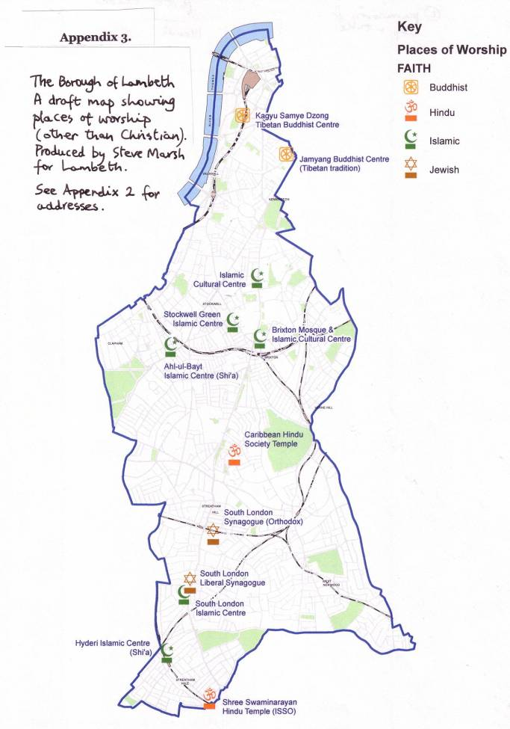Appendix 4.
INTER FAITH GROUPS IN SOUTH LONDON
(the twelve boroughs covered by the SLIFG)

* = council initiative (more or less)

South London Inter Faith Group
Contact: Revd Alan Gadd 020 8678 8977
secretary@southlondoninterfaith.org.uk
www.southlondoninterfaith.org.uk

Bexley Multi Faith Forum.
Contact: Prof Harbhajan Singh. 76 Battery Road SE28 020 8316 7746
Email: narinderkaur597@msn.com

Faiths Together in Croydon.
Contact: Revd Barry Goodwin. 020 8256 9637 barry.goodwin@southwark.anglican.org

Croydon Inter Faith Circle. (temporarily suspended)
Contact: Les and Angie Kemp. 020 8395 3851

Greenwich Multi-Faith Forum.
Contact: Rev Jesse Van der Valk. 020 8854 2302 jessevdvalk@aol.com

Thamesmead Inter Faith Forum.
Contact: Prof Harbhajan Singh. 76 Battery Road SE28 020 8316 7746
Email: narinderkaur597@msn.com

* Kingston Inter Faith Forum.
Contact: Jean Cousens. 020 8547 5023
Jean.Cousens@rbk.kingston.gov.uk

Lambeth Multi-Faith Action Group..
Contact: Rita Nunan, LAMAG. 22 Tenham Ave. SW2 4XR

Clapham and Stockwell Faith Forum.
Contact: Rebecca Brewin, 07958 353 652 info@csff.co.uk www.csff.co.uk

* Lambeth Faith Network.
Contact: Dinah-Mary Allotey. dmallotey@lambeth.gov.uk
www.lambeth.gov.uk/faithinlambeth

South London branch of CCJ (Council of Christians and Jews). Contact: Dorothy Lampert, 020 8673 9134
national website: www.ccj.org.uk

London South East (Lewisham & Bromley) Three Faiths Forum.
Contact: Linda de Lange. de_Lange@prontomail.com
national website: www.threefaithsforum.org.uk

London South East Three Faiths Forum Women's Group.
Contact: Linda de Lange. de_Lange@prontomail.com

* Faith in Lewisham
Contact: Alison Licorish. Alison.Licorish@lewisham.gov.uk

* Merton Inter Faith Forum
Contact: Monica Wambu. 020 8545 3864 monica.wambu@merton.gov.uk

Wimbledon Interfaith Group.
Contact: Andrew Wakefield andrew.d.wakefield@btopenworld.com

Tranquility Zone. A Baha’i initiative. A multi faith group meets monthly in Wimbledon to be still and peaceful and focus on a topic through readings, prayers, music and meditation.
Contact: John Elderton 020 8947 5250 john@aspinplan.com

South West London CCJ.
Contact: Helen Bramsted. 020 8542 9618 helericb@aol.com

* Richmond Multi Faith Forum
Contact: Suganaya Ranganathan. S.Ranganathan@richmond.gov.uk

Faith Around the Elephant (FATE).
Contact: Suzanne Keys. 020 7403 4655
faitharoundtheelephant@yahoo.co.uk

* Southwark Multi Faith Forum.
Contact: Trevor Udennis. 020 7525 5444

Sutton Faith and Belief Forum.
Contact: Mark Tomlinson. m.tomlinson.t21@btopenworld.com

* Wandsworth Multi-Faith Network.
Contact: Catriona Robertson. 020 8674 4610. overhere@surfaid.org
www.wcen.org.uk info@wcen.org.uk

Balham and Tooting Community Association (BATCA).
Contact: Kate Allan. 1 Ellerton Rd SW18 020 8870 1550
Allanraallan@aol.com

Appendix 5
Informal summary of findings in the 12 south London boroughs
(current at the time of writing)

Bexley.
Although the only place of worship other than Christian, is a gurdwara, there is a small but thriving Multi Faith Forum with members from all the main faiths. Chaired by Professor Harbhajan Singh, they have received funding for a booklet of inter faith engagement for use in local schools and are initiating conferences on the subjects of ‘The environment’ and ‘Addiction’ (drugs and gambling) in conjunction with the local council. One of the best events I’ve been to, was the Forum’s meeting on a Saturday afternoon in the hall belonging to a gurdwara, on the topic of prayer. There were 18 of us. A Christian, a Hindu, a Muslim and a Sikh – all members of the Forum – spoke about what prayer meant in her tradition (they were all women speakers). The personal sincerity of each speaker was palpable and
a very meaningful discussion followed (large numbers are not everything).
There is also the flourishing Oxleas multi faith mental health chaplaincy, which covers Bexley, Bromley and Greenwich. I joined them for a very interesting day conference and their co-ordinator, Qaisra Khan, has been extremely helpful.
The council Faith Link Contact (who, to be fair, is standing in for someone on maternity leave) and the chaplaincy and the inter faith group were unaware of each others existence. Things have moved on during the year and hopefully they are now all on each other’s mailing lists and planning a co-ordinated ‘inter faith’ stall at their annual summer community festival in June.

Bromley.
The largest borough in area but, besides Christian places, Bromley has only a synagogue, an Islamic centre and a Muslim school. Members of the synagogue attend the Three Faiths Forum which crosses the boundary from Lewisham. The designated Faith Link Contact
is head of Human Resources and so busy I was never able to speak to him. However, I did have a conversation with a council officer who told me that there is not much on ‘faith’ going on in Bromley at the moment. I was sent a draft of a booklet about the different religions for Bromley staff, a very good idea but there were many errors and it has now been shelved. (Southwark Multi Faith Forum has produced an excellent booklet about
the religions in everyday life called ‘A Mark of Faith’ – perhaps it could be adapted and used in Bromley and other boroughs.)

Croydon
Apart from an informal ‘inter faith circle’ meeting at the Unitarian Church, for friendship and meditation (whichis currently temporarily suspended), there had been a year or two
of lull in any organised inter faith activity in Croydon. Then ‘Faiths Together in Croydon’ was re-launched last October, at a very well attended meeting in the Council Chambers. This is an independent group of faith leaders and representatives, currently chaired by Revd Barry Goodwin, who organise their own inter faith dialogue meetings. They act as
a consultative forum on local issues for local government and the Council help out with venues and some secretarial support. They acquired funding from the FCCBF, for Penny Smith-Orr, the RE consultant for Croydon, to make a very thorough survey of the Borough of Croydon, identifying all the places of worship and who uses them and for what purposes.
The Croydon Religious Education Resource Centre (CRERC), run by Fauzia Ali, holds interesting inter faith events which seem to be well publicised.
Croydon is one of the most religiously diverse boroughs in the country, although Penny’s map reveals that the religious diversity is concentrated in the north west of the borough. The SLIFG had one of its most fascinating annual walks through this part of Croydon in 2002, visiting the Buddhist Centre, the Salvation Army Citadel, Croydon Mosque, the Jain Temple, Mayday Hospital Chapel, the Sikh Community Centre and St Michael and All Angels Anglican Church. It would seem that in this large borough with so many different places of worship, there is scope for more intimate local inter faith groups to evolve.

Greenwich
The Greenwich Multi-Faith Forum has been going for 12 years and organises regular
well attended events. It is well supported by leaders of the local faith communities and
is currently chaired by Revd Jesse van der Valk, who keeps the members and other interested parties well informed by email, of relevant activities and issues (eg a recent email came round requesting a regular worship space for a Christian congregation).
They act as a consultative forum for local issues for local government and committee meetings are often held in Woolwich Town Hall. The Mayor hosts an annual reception
for the GMFF members.
The Greenwich Peninsular Chaplaincy (which collaborates with the GMMF), has a pioneering role in multi faith community planning as the Peninsular is being redeveloped. It has a multi faith ministry to the construction and industrial workers and the new residents as they move in. (The Anglican chaplain, Malcolm Torry, is currently co-editing
a book – with me – of ‘good news’ inter faith stories from south London.)
Another inter faith group has just started up in Thamesmead, initiated by Professor Harbhajan Singh, to improve local inter faith understanding and community relations.
The SLIFG greatly enjoyed its annual Walk in 2004 through Plumstead when we visited the Greenwich Mosque, the Hindu Mandir, St Patrick’s RC Church, the Chinese Buddhist Temple and the Sikh Gurdwara. To our delight a similar walk is being arranged for this September, by a Sikh member of the GMFF – just what we hope will happen!

Kingston
Kingston is highly organised and communication and collaboration between the faith communities, the council, the SACRE and relevant council and voluntary organisations
is excellent. They all come together in the Kingston Multi Faith Forum which was founded in 2003 and meets regularly in the Guildhall. It is ‘serviced’ by Marian Morrison, who works for the Council but is not the FLC (the designated FLC seems not to be involved).
The Forum has formal ‘working arrangements’, representatives from all the diverse faith communities and is currently chaired by Rabbi Danny Rich. The agenda includes information sharing, addressing current issues and relevant council policy making, input from organisations such as the Police and ‘Street Pastors’, planning annual events such as Kingston Open Weekend, civic services (at church, mosque and synagogue) and special conferences. I spent the Saturday of their ‘open weekend’ in Kingston and was made welcome at services in both the Orthodox and the Liberal synagogues and visited the special exhibition at the Mosque. I have twice visited the Mosque since then, once for
a civic service and delicious lunch and once for an enlightening conversation with Major Rashid Laher.
The Kingston SACRE has produced a very helpful Directory of Places of Worship with contact details and useful information for schools. It recently organised an excellent 6th Form Conference, with FCCBF funding; key local faith leaders spoke on the Question and Answer panel. Very well prepared and executed, it was well attended and the young people gained a lot from it and want more. Could this be replicated in other boroughs?
At a ‘leaders’ level it is brilliant. There is a question about whether the ordinary members of faith ‘congregations’ meet – is there scope for some smaller informal groupings, for more personal grass-roots relationships?

Lambeth
There are two independent inter faith groups in Lambeth. LAMAG (Lambeth Multi-Faith Action Group) was founded in 1993; it organises at least two regular well-attended events each year, usually focussed on an issue of social and religious concern and held in a place of worship (often the South London Liberal Synagogue in Streatham or Corpus Christi
RC Church in Brixton).
The well established Stockwell Faith Forum, chaired by Catriona Robertson, last year became the CSFF (Clapham and Stockwell Faith Forum) and as from this year now has funding to employ Hannah Barker as the full time co-ordinator. They are developing
a very cutting edge and innovative programme including a Women’s Art Group, Round Table discussions on topical issues (eg wearing the niqab) and a teenage football club
and an excellent website.
Both these groups communicate well with the FLC and other council members and organisations such as the police.
The CCJ (Council of Christians and Jews) has a branch based in Streatham which meets regularly, often at the South London (Orthodox) Synagogue, and has interesting speakers and discussions (and visits to Israel/Palestine).
Lambeth is the only borough, I think, to employ a full time FLC. Dinah-Mary Allotey convenes the Lambeth ‘Faith Steering Group’ which includes representatives of many
of the diverse faith communities. They are currently debating what exactly is their role in relation to the Council, as many of the faith leaders are involved with the inter faith groups as well. Consultation, information sharing, resources and funding, influencing policy making, planning collaborative events for a Peace Week/Month, Holocaust Memorial Day, annual reception, working with local voluntary and statutory bodies –these are some of the items on the agenda. The FLC is also updating the directory of faith communities, and producing an excellent quarterly newsletter. Communication with the Lambeth SACRE needs to be improved.
The SLIFG has had three Walks in Lambeth – our very first one was in Streatham in 1997 and another one between Streatham and Brixton in 1999. The last was on July 9th 2005, just two days after the bombings; that was through Brixton, Stockwell and Kennington
– a very significant Walk of witness and solidarity.

Lewisham
Seven years ago, groundbreaking innovations were happening in Lewisham, culminating in a Faith Link Contact post and the establishing of the Faith in Lewisham Network. A Faith Review of the borough is currently being undertaken in collaboration with Coventry University.
The role of the Faith Link officer is to support faith based initiatives and community development. Inter faith events include an annual Holocaust Memorial Day. The borough has a very well established SACRE and RE Resource Centre, masterminded by RE consultant, Denise Chaplin (though there have been anxieties about whether funding would continue for this).
The Three Faiths Forum is a flourishing well-attended independent inter faith group with good numbers of Jews, Christians and Muslims meeting to discuss religious issues of topical interest. I went to an extremely good meeting on ‘Wearing the Veil’. There is also an offshoot group – a thriving Women’s Group which I have also attended, with regular members of all three faiths who meet for friendship and inter faith dialogue.
The Hindu Temple perhaps gets left out. I visited and was warmly welcomed and felt they would like to be included.

Merton
Merton Inter Faith Forum was revitalised at the end of 2005, but Christian support, I’m told, could be strengthened. The quarterly meetings are chaired by the chief executive
of the council. Its programme is geared to the council’s community cohesion policies.
An inter faith walk in Morden is planned for the Peace Week in September and a youth inter faith forum is to be launched by the end of 2007.
The independent Wimbledon Inter Faith Group has been active since 1993, but is struggling at the moment for want of new leaders and new active members from all of
the religious communities in the area – recently the participants have been almost entirely Christian. The SLIFG had a wonderful Walk through Wimbledon in 2003, collaborating with the Wimbledon Inter Faith Group.
There is a branch of the CCJ in Merton.
The Tranquillity Zone is a Baha’i initiative; a multi faith group meeting monthly, to be
still and peaceful and focus on a topic through readings, prayers, music and meditation.
The Ganapatti Hindu Temple, a Sikh Gurdwara, three mosques, a Reform Synagogue, the Buddhapadipa Thai Buddhist Temple and the biggest Ahmadiyyah Mosque in Europe are all located in Merton. However, although Merton is one of the most religiously diverse boroughs, there is apparently, an east/west divide with most of the places of worship situated in the more affluent west (Wimbledon) and most of the minority faith communities resident in the east (Mitcham). There could perhaps be a case for a new inter faith group in the Mitcham area.

Richmond
Nothing very much happening in Richmond that I can discover, although there are people there who don’t know each other who would like to see more happening! There is only one Orthodox synagogue other than Christian places. There used to be an inter faith group based at the Unitarian Church but that folded when the minister moved on. The FLC is keen but not sure how to set about it. There is a new person working with the SACRE on the RE syllabus who is interested in the inter faith dimension. There is a group of lay members at St Richard’s Church Ham who have arranged a well-attended annual service of inter faith prayers for peace the last four years. There is a Borough Dean who is interested. Richmond and Twickenham Libraries are hosting four evenings of sacred
story telling from the different religions, this May. There is a multi faith ‘Ethnic Minority Advocacy Group’. I’ve put them all in touch with each other recently. Maybe something will happen.

Southwark
Southwark is one of the most religiously diverse boroughs in the country. Southwark Multi-Faith Forum was founded in 2002. It acts as a consultative forum on local issues
for local government. The Forum produced an excellent booklet called ‘A Mark of Faith’, about the different religions.
Siriol Davies last year, made a fascinating survey for the Anglican Diocese of Southwark, mapping faith communities and inter faith relations in the Borough of Southwark (this is of course from a Christian perspective).
Based at the New Peckham Mosque in Cobourg Road, is a branch of the Dialogue Society, a Turkish Muslim group which arranges inter faith meetings to promote dialogue and understanding.
The new Samye Dzong Tibetan Buddhist Centre in Manor Place offers spiritual teaching and holistic therapies and resources – open to all Buddhist and non-Buddhist alike.
A new local inter faith group kicked off last year - FATE (Faith Around The Elephant) inspired originally following exchange visits between a group from Southwark Anglican Cathedral and the Hyderi Shi’a Muslim Centre in Streatham. These prompted the Southwark group, led by Suzanne Keys, to find out more about the multi faith scene
in their own area and FATE was born. The first meetings, for friendship and better understanding of each other’s religions, have centred around discussions of relevant spiritual and social topics – and shared food.
The SLIFG annual Walk will take place in July this year in Southwark in collaboration with FATE. In 2001 we walked from the Gurdwara in East Dulwich, to Peckham and
the Muslim Women’s Association and the Mosque in Rye Lane and finished at St Mary’s Greek Orthodox Cathedral in Camberwell

Sutton
Sutton is one of the least religiously diverse boroughs in the country, with just one synagogue! And yet it has a new and active ‘Faith and Belief Forum’ with members from many religions. It is an independent group, chaired by a lay person, with plenty of imaginative plans for the future. The FLC and council members attended the meeting
I was at and I understand the council supports the group with free venue and helps out with secretarial facilities.
It might consider liaising with the well-established and vibrant Elmbridge Multi-Faith Forum across the boundary?

Wandsworth
In 2002 a valuable comprehensive survey, including the faith communities, was made of Wandsworth by Catriona Robertson. The Wandsworth Multi-Faith Network, co-ordinated by Catriona, is part of the Wandsworth Community Empowerment Network. One of the Forum’s meetings was probably the most vibrant grass-roots meeting I went to last year! Over 40 people representing all the major faiths gathered in a crowded upper room in Tooting. Some really exciting and innovative plans were debated – including a particular project about sharing assets (eg bartering skills for premises) . . . . However, funding for the Forum is threatened!
Another new group is taking off, BATCA (Balham and Tooting Community Association) originally in response to the July 2005 bombings, as an expression of solidarity between the different ethnic and faith communities.
Two of our best Walks have been in Wandsworth. In 1998 through Tooting, when we visited St Anselm’s RC Church, the Hindu Temple, Tooting Islamic Centre, the Sikh Khalsa Centre, the Church of God of Prophecy and the Shi’a Islamic Centre. And our Millennium Walk from Balham Mosque to the Buddhist Peace Pagoda in Battersea Park, via the Radha Krishna Hindu Temple, the Nightingale Jewish Nursing Home, Holy Trinity Hospice and All Saints Anglican Church.

Appendix 6.
This article appeared in The Times newspaper Nov 18th 2006

