That's when I lost them.
That's my Remembrance Day.

This year saw the death of the last British soldier from the Great War, Harry Patch, who had done further great service in recent years by his honesty and independence of thought. Some of Harry’s words, about his three friends who died in the explosion that severely injured him, appeared on the programme at ‘Inter Faith Prayers for Peace on Remembrance Sunday’ at Southwark Cathedral: ‘September 22nd, half-past ten at night. That's when I lost them. That's my Remembrance Day’.

The other thing giving special significance to Remembrance Sunday this year was the media coverage of the war in Afghanistan, bringing images of death and injury into our homes day by day, raising issues about which we disagree and dispute.
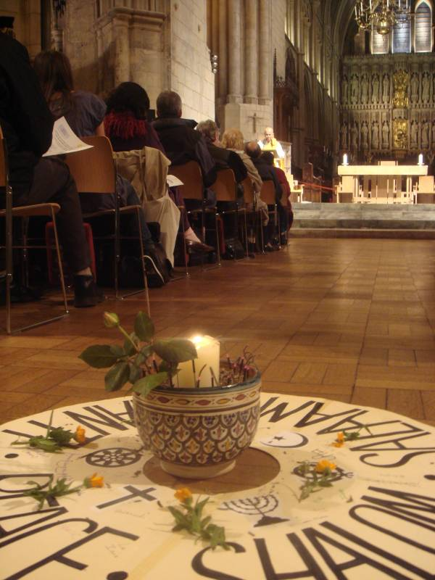
Photo: Barry Green

This was the tenth year that South London Inter Faith Group had held a Remembrance Sunday event, and the practice seems to be spreading. This year Greenwich Multi Faith Forum again arranged a Multi Faith Act of Remembrance at the Firepower Museum in Woolwich, and Kingston inter Faith Forum organised a new event, with the Sarvoday Hindu Association, at Hampton Court Palace. The Cathedral event was arranged jointly with the World Congress of Faiths and was one of five components of the Cathedral’s World Faiths Season.

There were beautiful displays of poppies in the Cathedral, reminding us that Remembrance Sunday has its origins in the human carnage of the Great War. Soldiers died in vast numbers in areas of Belgium and France where red poppies grew in profusion and came to symbolise the blood that was shed.

Remembrance Sunday is not so much a Christian festival – no mention in the Common Worship Calendar and just a footnote in the Collects - as a civic observance that is marked in most churches. One of the purposes of inter faith events is to show that Remembrance Sunday is a civic observance meaningful for all people of faith. This was made very clear this year when the Muslim Council of Britain published a report called ‘Remembering the Brave: The Muslim Contribution to Britain’s Armed Forces’. A second purpose is to widen our remembrance to all who have died, indeed are dying at any given moment, in all wars, conflicts, acts of terrorism and so on. Aware of this wider picture, the natural response of people of faith is to pray for peace.

During the hour from 4.30pm, after a welcome from Canon Bruce Saunders, prayers for peace were offered from Muslim, Buddhist, Christian, Hindu, Sikh, Zoroastrian, Baha’i, Jain, and Jewish faith traditions. Appropriately, the Jewish prayer was prayed by Rabbi Jackie Tabick, Chair of the World Congress of Faiths, setting the seal on this collaborative event.

Alan Gadd

