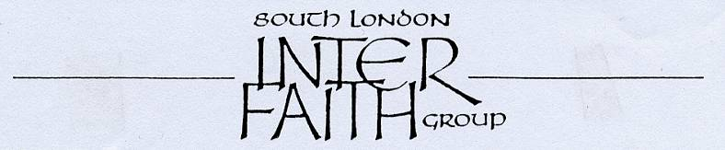
www.southlondoninterfaith.org.uk

Meeting for representatives of local inter faith organisations across South London

Sunday 4 October 2009, 3pm - 5pm

All Saints’ Church, Prince of Wales Drive, London SW11 4BD

All Saints’ Church faces Battersea Park and is the third building from the large roundabout at the junction of Prince of Wales Drive and Queenstown Road. All Saints’ is within a few minutes walk from both Battersea Park and Queenstown Road stations and from bus routes 137, 156, 44, 344, and 452.

Following successful meetings in the past two years, South London Inter Faith Group is again convening a meeting for representatives of inter faith organisations across South London. Invitations have been sent to 24 organisations* and also to the SACREs in the 12 Boroughs.
The meeting is open to all who have an interest.

Programme

Welcomes and introduction

Brief news and plans from each organisation
with special emphasis on National Inter Faith Week, 15-21 November 2009

Olympic Year 2012
Sarah Thorley will share her experience of arranging 13 Inter Faith Walks in different parts of South London with the aim of encouraging organisations to plan walks in their own areas in 2012

Buffet meal at 5pm

Do join us on 4 October. It may be that you are already active in one of the 24 organisations, or that you would like to get in touch with one of the groups, or meet others interested in starting another one. Or you may simply have a general interest in encouraging these developments.

Alan Gadd, Secretary
24 Holmewood Gardens, London SW2 3RS
020 8678 8977
secretary@southlondoninterfaith.org.uk

__________________________________________________________________________________________
* Bexley Multi Faith Forum, Faiths Together in Croydon, Greenwich Multi Faith Forum, Thamesmead Inter Faith Forum, Kingston Inter Faith Forum, Faithful Friends (Kingston & Ham), Faiths Together in Lambeth (FTiL), Lambeth Multi Faith Action Group (LAMAG), Clapham & Stockwell Faith Forum, South London Branch of The CCJ, Faith in Lewisham, London South East Three Faith Forum, London SE Three Faith Forum Women's Group, Merton Inter Faith Forum, Wimbledon Inter Faith Group, Tranquillity Zone, South West London Branch of The CCJ, Richmond Inter Faith Forum, Southwark Multi Faith Forum, Faith Around The Elephant (FATE), Sutton Faith and Belief Forum, Wandsworth Multi Faith Network, Balham & Tooting Community Association (BATCA), Furzedown Festival

