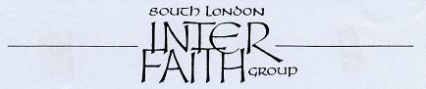

www.southlondoninterfaith.org.uk


www.worldfaiths.org

INTER FAITH PRAYERS FOR PEACE
ON REMEMBRANCE SUNDAY

Southwark Cathedral, London Bridge, SE1 9DA

Sunday 8 November 2009 at 4.15pm

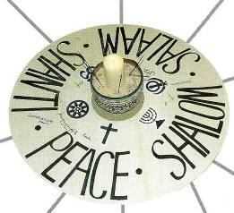

The peace candle has provided a visual focus at Remembrance Sunday events which have been held in South London each year since 2001

The World Congress of Faiths and South London Inter Faith Group are joining together for a Remembrance Sunday event in Southwark Cathedral this year. Please be seated in silence by 4.15pm. During the hour from 4.30pm prayers, readings and reflections will be offered by invited representatives of the faith traditions. At 5.30pm we shall move into the adjoining Cathedral Education Centre where a vegetarian meal will be shared.

The World Congress of Faiths has arranged that the
Global Ethic Exhibition will be in Southwark Cathedral from 17 October until 12 November.
(This exhibition is closely associated with theologian Hans Küng.)

Also in Southwark Cathedral, the World Congress of Faiths is holding a
Moral Maze on ‘Greed or Need?’ at 7pm on Thursday 5 November.

Southwark Cathedral is located at the southern end of London Bridge, just a few minutes walk from the London Bridge train, tube and bus stations.
Car parking without charge is possible in the local streets on Sundays, but the streets are narrow and crowded and public transport is recommended.

Enquiries to Alan Gadd at 020 8678 8977 or secretary@southlondoninterfaith.org.uk

