Were you there?
The weekend of July 14/15th 2012, twelve inter faith walks
took place in different parts of south London More than 500 people joined in.
23 Christian churches, 7 Hindu temples,
8 Jewish synagogues, 5 Buddhist temples,
4 Sikh gurdwaras and 15 Islamic centres were visited

Come and see what happened!

INTER FAITH WALKS

EXHIBITION SOUTHWARK CATHEDRAL
JULY 16 - 28th 2013
Opening hours: www.southwark.anglican.org/cathedral or 020 7367 6700

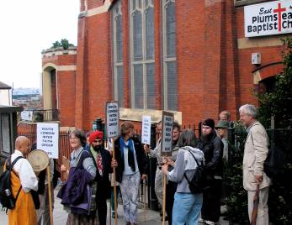Could this exhibition be a resource for you to support or organise an inter faith walk where you live?

Many
said they hoped such walks would happen regularly

It seems that the Almighty loves diversity!

We learned a lot from talking to
each other



invite you to the launch of the exhibition at Southwark Cathedral
London Bridge SE1
on Tuesday 16th July 6.15 – 7.30pm
including a short film

OPEN TO ALL
If you were involved in any way with the inter faith walks co-ordinated by the South London Inter Faith Group last year
as organiser or host or walker we would love to see you. Come and look at the photographs, read the reports, watch the short film and meet each other.
Bring members of your community with you.
Consider whether you might show this (travelling) exhibition in your own place of worship or community hall.

For more information go to: www.southlondoninterfaith.org.uk or email: secretary@southlondoninterfaith.org.uk

A
unique opportunity

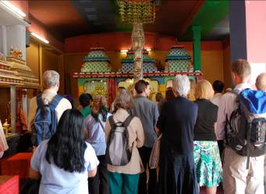

This was truly a
spiritual day
All
our hosts were
wonderfully kind

