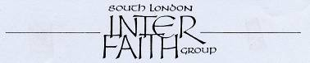
www.southlondoninterfaith.org.uk
More than 30 years committed to greater understanding among people of faith

SUMMER 2012 NEWSLETTER

SLIFG future events
London Inter faith walks on Saturday July 14 and Sunday July 15
South London Inter Faith Group has encouraged and supported a coordinated set of inter faith walks this year immediately before the Olympics and Paralympics. There will be walks right across the southern part London during the weekend 14th and 15th July 2012. Local groups have chosen the Saturday or the Sunday, or both, depending on local factors.

The aim is to use this time when the global spotlight is on London to celebrate the multi faith character of London and to demonstrate the inter faith collaboration that is taking place. Planning meetings took place on 8th February at Southwark Cathedral Education Centre and on 15th May at City Hall. There was an encouraging response at the planning meetings and there will be 11 walks in 10 different boroughs: Croydon, Greenwich, Hounslow, Kingston, Lambeth, Merton, Lewisham, Richmond, Southwark, and Wandsworth. Information on the 11 starting points may be found on Sarah Thorley’s map.
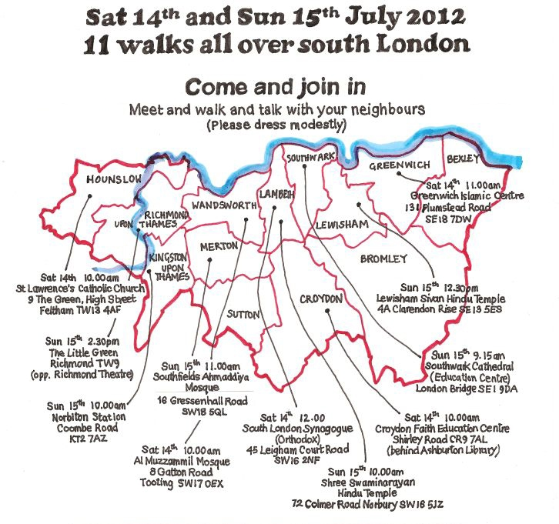
If you would like to find out the details of a particular walk, please send your enquiry in an e-mail to secretary@southlondoninterfaith.org.uk with ‘2012 inter faith walks’ in the subject line. SLIFG will forward your enquiry to the appropriate contact person. Your enquiry should specify the starting point given on the map. We hope you will feel inspired to join one of the walks that weekend. Do invite friends and neighbours and members of your faith community to accompany you. If you have never been on an inter faith walk before this is the time!
Please publicise your ‘local’ walk as much as possible and we really would like as full a record of each event as possible too, maybe for an exhibition in the autumn - and indeed for the long term 'legacy.'

Monthly lunchtime meetings
SLIFG holds simple lunchtime meetings on the last Thursday of each month at Streatham Friends Meeting House, Redlands Way, Roupell Park Estate, Brixton Hill, SW2 3LU. A vegetarian lunch is served at 12.30pm then from 1pm to 2pm a chance to share inter faith news and experiences, and discuss any matters of current concern to SLIFG. Next meetings are: 28 June, 26 July, 30 August, 27 September. For more information and if you can come contact Alan Gadd: alangadd@yahoo.co.uk, 8678-8977. Meetings are well-received, generally with a theme and sometimes a speaker. The meeting during the Christian season of Lent for example focussed on fasting and involved four speakers.

SLIFG news
AGM on Sunday 11 March at the Ahmadiyya Mosque, Morden – there was the chance to explore this fascinating building (for which we are grateful to our hosts) before our shared food and business meeting. At the meeting the following committee members were re-elected for 2012/13: Rashid Laher as Secretary, Ebrahim Rashid as Treasurer, Rizwan AliBhai, Helen Bailey, Balbir Singh Bakhshi, Tima Beckett, Alan Gadd, Ganesh Lall, Thelma Lewis, Sally Smith. And a huge thank you to Louis Kleinman who previously served and has now stood down. Sarah Thorley and Siriol Davies remain involved and committed and we thank them too for their service. Christian, Hindu, Muslim and Sikh faith traditions are represented on the current committee. If you would like to read AGM papers contact the Secretary.

Membership for 2012
If you have still not, please send your annual subscription of £10 (if you can afford it) now to the Treasurer Ebrahim Rashid, 15 Rainbow Street, London SE5 7TB, (ebrahim.rashid@gmail.com ) as per your subscription renewal notice mailing. If you can, do renew by standing order if possible.

Bottom of Form
Top of Form
A large print version of this newsletter is available on request

Do you have any news, events, new ideas or just want to find out more? Please contact the Secretary Rashid Laher: secretary@southlondoninterfaith.org.uk

