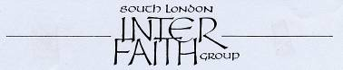
www.southlondoninterfaith.org.uk

NEWSLETTER FEBRUARY 2011

The Annual General Meeting

The AGM will take place on Sunday 13th March at 4pm, followed by a bring-and-share vegetarian meal at 6pm. In recognition that March is ‘Celebrating RE’ month, we will meet at Gatton School, the purpose built Muslim primary school near Tooting Broadway.

First we will have the business meeting, with the annual report and financial statement for 2010, committee elections for 2011/12, and a small amendment to the constitution, which the committee is proposing, to make clear that those elected to the committee and those who propose and second them must be members of SLIFG.

In the second part of the meeting, Sarah Thorley will help us in ‘Celebrating RE – exploring values and beliefs for tomorrow’s world’. Sarah has been deeply involved with the inter faith section of the Celebrating RE website and you can see her work at www.celebratingre.org/index.php/what-can-you-do/inter-faith-if-groups.

There will also be a tour of Gatton School conducted by a member of staff.

The bring and share meal (vegetarian food and soft drinks please) will follow from 6pm to 6.30pm. Note that we will not have facilities for heating food, though a hot water urn is expected to be available.

Do join us if you can and bring your friends. Please display the enclosed flyer if you have the opportunity.

Election of the committee

The constitution gives the AGM the responsibility to ‘elect the secretary and treasurer and other members of the committee, making every effort to include representatives of the main faiths in South London’. The whole committee is freshly elected at each AGM, but serving committee members have often been nominated and elected annually for several years to give continuity. Many of the members of the 2010/11 committee may be willing to be nominated again this year.

I myself have been elected as secretary for 5 successive years. However I will not be accepting nomination as secretary for 2011/12, so the AGM will be seeking to elect a new secretary.

A nomination form is enclosed with the present mailing. The constitution states that ‘nominations for officers and members of the committee should be submitted to the secretary seven days before the AGM’.

It may be helpful to give a reminder of those who were elected a year ago to the 2010/11 committee:
Rizwan Ali Bhai, Helen Bailey, Balbir Singh Bakhshi, Tima Beckett, Alan Gadd (as secretary), Louis Kleinman, Rashid Laher, Ganesh Lall, Thelma Lewis, Bernard Mordan and Ebrahim Rashid (as treasurer).

Buddhist, Christian, Hindu, Jewish, Muslim and Sikh faith traditions are represented among the elected committee members.

The 2010/11 Committee reappointed Bernard Mordan as membership secretary and invited Sarah Thorley and Siriol Davies to continue as co-opted members, which they agreed to do. The committee has been greatly assisted by John Beckett as minutes secretary and by Lillalou Hughes and Mark Burrell who have joined John and Tima in the postal mailing work.

Subscriptions

Bernard Mordan was very heartened to have received 56 subscriptions for 2011 by the end of January. If you are still due to pay a subscription, it would be helpful to receive it before or at the AGM. Additional copies of the form are available on request.
Anniversaries

2011 sees the 30th anniversary of the founding of South London Inter Faith Group. The committee will be considering how this is to be marked, and if you have any suggestions it would be good to make them at the AGM.

But this is also a significant anniversary year for another inter faith organisation. The World Congress of Faiths (www.worldfaiths.org) has its origin in the Congress, organised by Sir Francis Younghusband, which took place in London in 1936. The organisation’s constitution uses its fuller title of ‘The World Congress of Faiths (The Inter-Faith Fellowship)’ A member of WCF is typically a person who is committed to one or other of the world faith traditions, but who does not expect any one tradition to furnish all available wisdom and spiritual insight, expecting instead to benefit from the challenges and enrichments offered by engagement with diverse expressions of faith and belief. WCF‘s journal is the attractively produced ‘Interreligious Insight’, of which the Revd Alan Race is the Editor in Chief.

The 75th anniversary of WCF will be marked by a special service at 6.30pm on Sunday 24th July at St Martin in the Fields (Trafalgar Square). The theme will be Compassion, with readings and music from many faith traditions. Rabbi Jackie Tabick, Chair of WCF, will give the address.

St Christopher’s Hospice

Following the meeting at St Christopher’s Hospice on 1st November, the Revd Andrew Goodhead, Spiritual Care Lead, and Pat Morgan, a Principal Social Worker, visited the SLIFG lunch meeting at Streatham Friends Meeting House on Thursday 16th December for a helpful discussion.

Andrew is seeking to build up a multi-faith network of persons ready to assist with pastoral care both for residents and for the much greater number being offered end-of-life care in the community. A further meeting to that end has now been arranged at St Christopher’s on Thursday 10th March, 7pm – 9pm.

If you plan to attend on 10th March, please inform Linda Fox, Spiritual Care Administrator, St Christopher's Hospice, 51-59 Lawrie Park Road, Sydenham SE26 6DZ, 020 8768 4605, l.fox@stchristophers.org.uk.

World Interfaith Harmony Week and National Inter Faith Week

Last year the UN General Assembly adopted a proposal from Jordan that the first week in February be designated World Interfaith Harmony Week. A particular focus of the Week is that Interfaith Harmony Breakfasts should take place on the first Thursday of February.

In this country the establishment in 2009 of an annual Inter Faith Week, taking place in November, has led to some hesitation about the new February idea. However the World Congress of Faiths has taken up the breakfast initiative and an Interfaith Harmony Breakfast duly took place in South London on 3rd February. A brief report has been posted on our website at www.southlondoninterfaith.org.uk/events-notified/.

Meanwhile, the Inter Faith network for the UK has announced that a third National Inter Faith Week will run in England, Wales and Northern Ireland from 20th until 26th November, and in Scotland a week later.

Thank you

Since this will be the final Newsletter during my period of office as secretary, I would like to thank everyone for the privilege of occupying this role during the past 5 years. I have felt greatly supported by all of my illustrious predecessors as secretary and enormously grateful to all those who have served as committee members and in

many other ways.
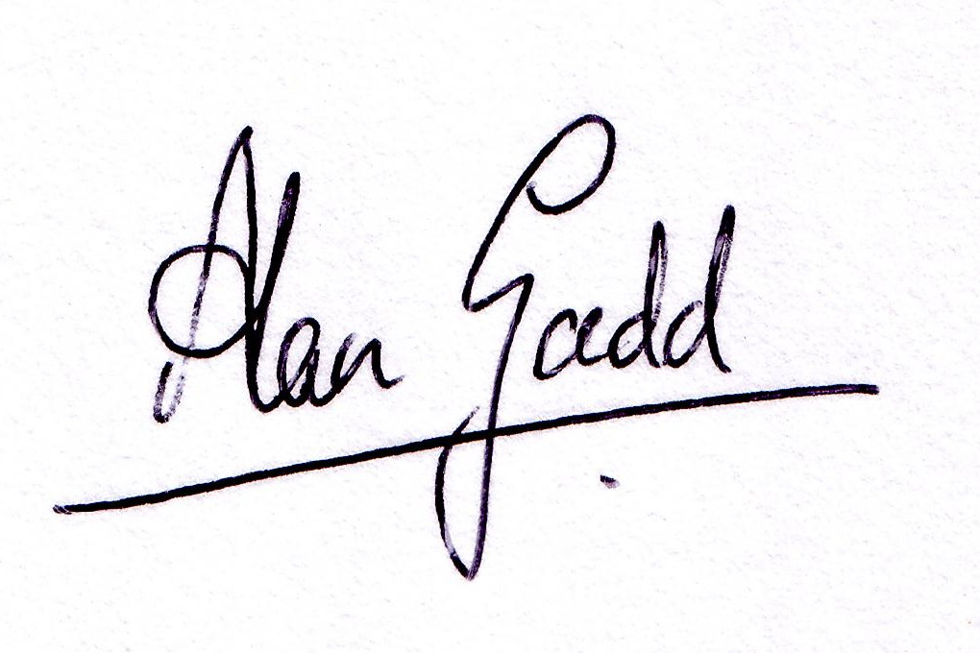

If you would like to enquire about any of the items in this Newsletter please contact the Secretary,
The Secretary, 24 Holmewood Gardens, London SW2 3RS
020 8678 8977 secretary@southlondoninterfaith.org.uk

