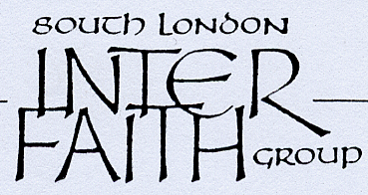

2012 INTER FAITH WALKS REVIEW

WEDNESDAY 28 NOVEMBER 6.15 - 8.15pm
AT SOUTHWARK CATHEDRAL
(in the Education Centre)

* * * * *
* Come and celebrate our achievements
on that July weekend
Share what you did and discover - in words and pictures (including a film) - what happened on
the other walks

* Come and discuss What Next? Hear about developments in Southwark and Bromley and tell us about what’s happening in your patch

* Come and share a simple meal (provided) and enjoy each other’s company – bring a friend

* * * * *
As the following Sunday will be Advent Sunday,
we shall start the evening by hearing how the Cathedral marks this significant four week period before Christmas and what it means to Christians.
You are most welcome to attend choral evensong at the Cathedral from 5.30-6.15 on the 28th

Southwark Cathedral is alongside London Bridge.
The Education Centre is located in the Cathedral extension. If facing the Cathedral (and the River), walk left round to the west end of the Cathedral, go up the steps, through the door and the Education Centre is on the left.

More info. - Sarah Thorley: thorleysarah@yahoo.co.uk or 020 8674 5447

