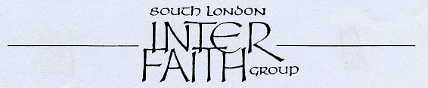
30 years committed to greater understanding among people of faith

www.southlondoninterfaith.org.uk

Wednesday 11th May 2011 at 5pm

a visit to

Kagyu Samye Dzong London Tibetan Buddhist Centre
15 Spa Road, Bermondsey, London, SE16 3SA

http://london.samye.org/london/

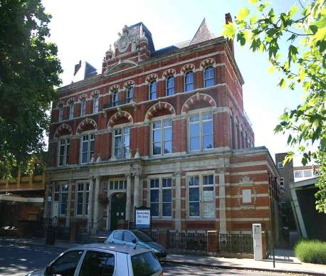

After 12 years in London, Kagyu Samye Dzong finally opened the doors of its long term home at 15 Spa Road on Sunday 20th June 2010.

In 2007 SLIFG visited the Manor Place centre of Kagyu Samye Dzong London during that year’s Inter Faith Walk. Now we are delighted to have an opportunity to visit the new Spa Road centre.

We are grateful to Lama Zangmo for the possibility of arranging this visit
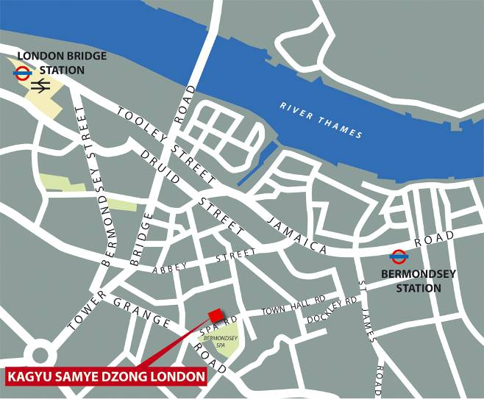

The nearest tube station is Bermondsey on the Jubilee Line

These buses pass near the centre:
1, 78, 188, 42, 47, 381 & C10

Parking in Spa Road and nearby streets is on a ‘Pay and Display’ basis until 6.30pm on weekday evenings

Out of courtesy to our hosts we need to let them know how many of us are coming.
Please would you inform Alan Gadd?

Contact: Alan Gadd, 24 Holmewood Gardens, SW2 3RS
020 8678 8977 or alangadd@yahoo.co.uk

