
36 years committed to greater understanding among people of faith

www.southlondonintefaith.org.uk

Annual General Meeting 2017
and bring and share vegetarian meal
(open to all: do invite your friends to accompany you)

Sunday 19th March at 4pm

Christ Church Streatham
www.christchurchstreatham.org.uk
Christ Church Road, London SW2 3ET

Christ Church is situated on the A205 (South Circular Road), near the crossroads with the A23 (Streatham Hill - Brixton Hill).

Buses 45, 57, 59, 109, 118, 133, 159, 201, 250 and 333 stop nearby. There are good bus links to Brixton and Streatham Hill Stations. Parking is unrestricted and free of charge in local streets.

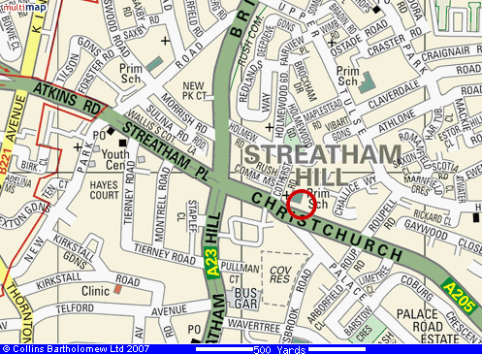

Programme

4pm Arrivals
We meet in the Parish Room – enter from the yard on the north side of the church

4.15pm Business Meeting
Annual Report and Financial Statement for 2016
Election of Secretary, Treasurer and Committee for 2017/18
Any Other Business

5.15pm Shared Meal
Please bring vegetarian items to share

Please let us know if you expect to attend the AGM.

Enquiries to Phillipe Cotgreave de Rahman 07956 441 911 or secretary@southlondoninterfaith.org.uk

