
37 years committed to greater understanding among people of faith

www.southlondonintefaith.org.uk

Annual General Meeting 2018
and bring and share vegetarian meal
(open to all: do invite your friends to accompany you)

Sunday 18th March at 4pm

St Laurence Church, Catford
www.stlaurencecatford.org.uk
37 Bromley Road, London SE6 2TS

St Laurence Church is situated on the A21, south of the junction with the South Circular Road; a 2 minute walk from the Catford one-way system.

Buses 47, 54, 75, 124, 136, 160, 171, 181, 185, 199, 202, 208, 284 and 336.

Trains to Catford and Catford Bridge are only a 5 minute walk.
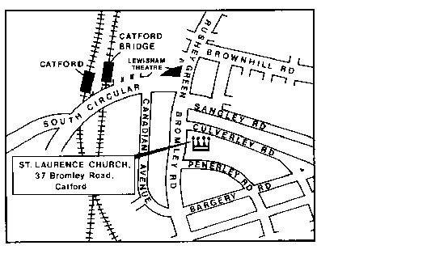

Programme

4pm Arrivals

4.15pm Business Meeting
Annual Report and Financial Statement for 2017
Election of Officers (Chair, Secretary, Treasurer) and Committee for 2018/19
Any Other Business

5.15pm Shared Meal
Please bring vegetarian items to share

Please let us know if you expect to attend the AGM.

Enquiries to Phillipe Cotgreave de Rahman 07956 441 911 or secretary@southlondoninterfaith.org.uk

