
35 years committed to greater understanding among people of faith

www.southlondonintefaith.org.uk

Annual General Meeting 2016
with a bring and share vegetarian meal
This event is open to all: do invite your friends to come with you.

Sunday 13th March at 4pm

South London Liberal Synagogue
www.southlondon.org
1 Prentis Road, Streatham, London SW16 1QB

The Synagogue in Prentis Road is just a few yards from the junction with Streatham High Road.
Streatham High Road is served by numerous bus routes, but because it is narrow near Prentis Road the bus stops are a short walk further north, just beyond Becmead Avenue
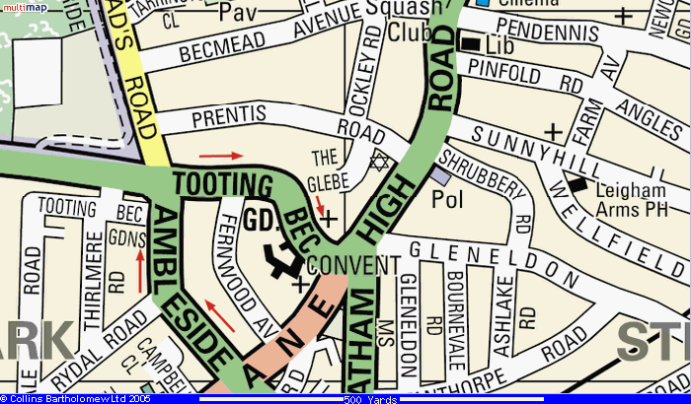

Programme

4pm Arrivals

4.15pm Business Meeting
Annual Report and Financial Statement for 2015
Election of Secretary, Treasurer and Committee for 2016/17
Any Other Business

5.30pm Shared Meal
Please bring vegetarian items to share

SLIFG is delighted that Rabbi Janet Darley is among those who have expressed their intention to be present at this year’s AGM.

Enquiries to Rashid Laher 020 8541 1330, 07766 327 989 or secretary@southlondoninterfaith.org.uk

