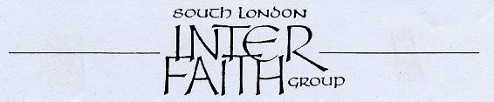
More than 30 years committed to greater understanding among people of faith

www.southlondonintefaith.org.uk

Annual General Meeting 2013
followed by a shared meal
Please bring vegetarian food to share with others.
This event is open to all: do invite your friends to come with you.

Sunday 10th March at 4pm

at Trinity Hospice, Clapham Common
(in the Mulberry Room)
30 Clapham Common North Side, SW4 ORN

Trinity Hospice is located on the North Side of Clapham Common, at the junctions with Long Road and The Chase. It is 5-10 minutes walk from Clapham Common underground station on the Northern Line. Buses 35, 37, 88, 137, 155 and 345 all stop nearby. No parking in the Hospice grounds, but street parking is free on Sundays.

Ask at the reception desk for the SLIFG AGM, taking place in the Mulberry Room.

We are grateful to Michael Savage, Spiritual Care Lead, for his help in arranging this meeting.
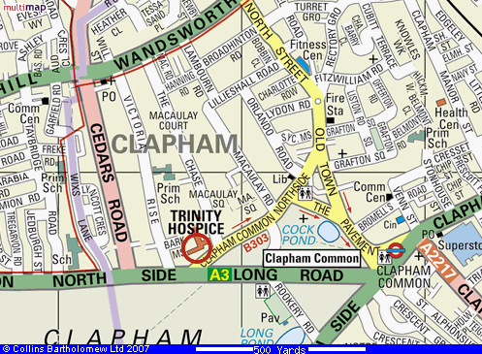

Programme

4pm Welcome by Michael Savage

4.15pm Business Meeting
Annual Report and Financial Statement for 2012
Election of Secretary, Treasurer and Committee for 2013/14
Any Other Business

5pm Inter Faith Walks: 2012 and after - including a 20 minute film!
Sarah Thorley and others

6pm Bring and Share Meal (a kitchen is available for heating food)

Enquiries to Rashid Laher 020 8541 1330 or 07766 379 989 or secretary@southlondoninterfaith.org.uk

