How to get to Streatham Friends Meeting House

Redlands Way, Roupell Park Estate, Brixton Hill, SW2 3LU

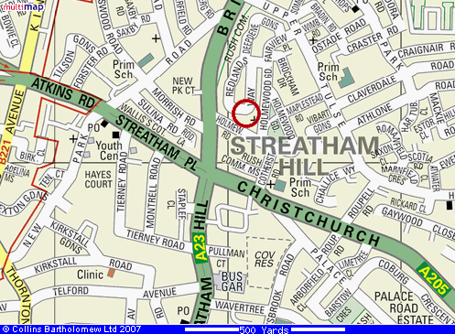

Streatham Friends Meeting House is very near the junction of the A23 (Brixton Hill → Streatham Hill) and the A205 (South Circular Road).

Travel by bus 45, 59, 109, 118, 133, 159, 250 or 333 to the Holmewood Road bus stop (in Brixton Hill, near New Park Court on the map above). From Holmewood Road bus stop there is a footpath leading immediately to Streatham Friends Meeting House, and a large sign is visible from the main road.

Christchurch Road bus stop (just south of the A23/A205 junction) is served by other buses: 57, 137, 201 and 417.

By tube, go to Brixton (Victoria Line), then take bus 45, 59, 109, 118, 133, 159, 250 or 333 to Holmewood Road bus stop.

By rail, go to Streatham Hill station, then take bus 59, 109, 118, 133, 250 or 333 to Holmewood Road bus stop.

Parking at lunchtime is now very difficult. Redlands Way is part of the Roupell Park Estate, where car parking is not possible without a permit, and a fine will result. Unfortunately, nearby Holmewood Gardens and neighbouring streets became a Controlled Parking Zone on 2nd October 2017. The controls apply between 12 noon and 2pm, Monday – Friday. During periods of control, many parking spaces are now restricted to resident permit-holders; there are also spaces where non-residents can purchase a maximum of 1 hour of parking by telephone.

Just a little further away, there are streets where the no-parking period is 10am – 12 noon. One such street is Elm Park, a turning off Brixton Hill, opposite Brixton Prison. From Elm Park it would take about 10 minutes to walk to the Friends Meeting House. Buses up Brixton Hill could also be used.

