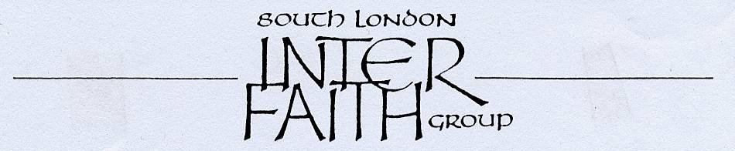

PRAYERS FOR WORLD PEACE

ON REMEMBRANCE SUNDAY

Sunday 13 November 2011 at 1.00pm

Guru Har Rai Sikh Gurdwara
58 Lower Marsh Lane, Kingston-upon-Thames, KT1 3BJ



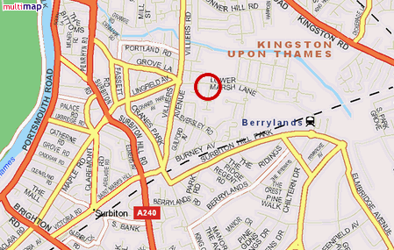

PROPOSED PROGRAMME

1.00pm Arrive in time to observe last part of Gurdwara worship

1.30pm Inter Faith Prayers for Peace
Invited representatives of several faiths will offer prayers, readings or reflections.
If you would like to contribute a short reading or prayer, that would be lovely.
Please contact Rashid Laher to arrange this.

2.30pm Langar (food)

(Please notify in advance dietary, disability or special considerations)

The Gurdwara is located in Lower Marsh Lane and is 5 minutes walk from Berrylands Station.
There is unrestricted parking on Sundays in Lower Marsh Lane.

Please dress modestly and be ready to remove your shoes and cover your heads on entry.

Enquiries to Rashid Laher at 077 6632 7989 or secretary@southlondoninterfaith.org.uk

