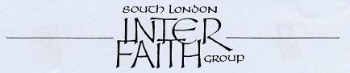

www.southlondoninterfaith.org.uk

INTER FAITH PRAYERS FOR PEACE
ON REMEMBRANCE SUNDAY

The Memorial Hospital, Shooters Hill, SE18 3RG

Sunday 14 November 2010 at 12 noon

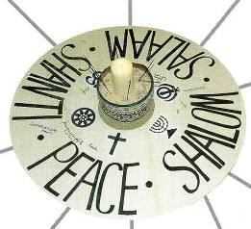

The peace candle has provided a visual focus at Remembrance Sunday events which have been held in South London each year since 2001

Mindful of continuing wars and conflicts of every kind, South London Inter Faith Group has marked Remembrance Sunday with Inter Faith Prayers for Peace every year since 2001. This year we are working with our member Qaisra Khan, the Spiritual and Cultural Care Coordinator for Oxleas NHS Foundation Trust, to arrange a Remembrance Sunday event on Sunday 14th November at The Memorial Hospital in Shooters Hill at 12 noon. Lunch will be provided at 1pm.

Major refurbishment works have now been completed so it is possible once again to commemorate Remembrance Sunday at the Memorial Hospital. The Hospital was built in 1925 as a memorial to victims of the Great War, so has a particular link with Remembrance Sunday.

The 12 noon start will make it possible for those who wish to go on after lunch to the nearby Firepower Museum in Woolwich for the annual Multi Faith Act of Remembrance (starts 3pm).

If you would like to contribute a short reading or prayer, that would be lovely. Please contact Alan Gadd to arrange this.

Bus 89 from Lewisham or Welling stations. Bus 244 from Woolwich Arsenal station.
Bus 486 from North Greenwich or Welling stations.
Car parking is available at the Memorial Hospital.

Enquiries to Alan Gadd at 020 8678 8977 or secretary@southlondoninterfaith.org.uk

