15 – 21 November 2015 is National Inter Faith Week .....

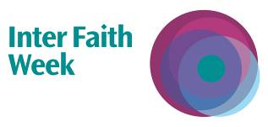

Conversations for the Soul and Remembrance Prayers for Peace

Multi-Faith Remembrance Prayers and Readings for Peace
followed by One to One Inter Faith Conversations about beliefs and practices

Sunday 15 November, 2.30pm
at the Hyderi Islamic Centre
26 Estreham Road, SW16 5PQ

supported by South London Inter Faith Group and Faiths Together in Lambeth

Programme

14.30 -14.40 - Welcome and Introduction

14.40 - 15.10 - Interfaith Prayers and Readings for Peace
Buddhist, Christian, Hindu, Jewish, Muslim and Sikh contributions

15.10 - 16.10 (or Maghrib Prayer time) - Conversations for the Soul
jointly organised by Shaykh Jaffer Ladak and John Woodhouse

Break for Maghrib Prayers

Reconvene after prayers for more conversations, tea, refreshments and departure.

