Happy Birthday: Jesus and Muhammad

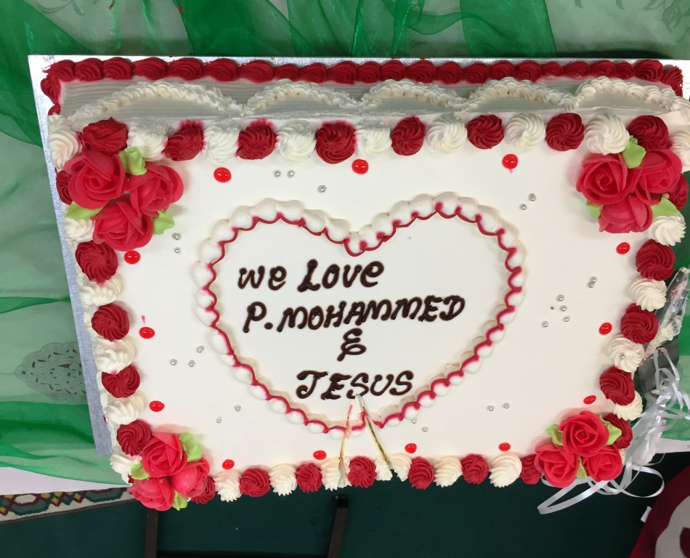

Between these religions there is no hate
Two births today we celebrate.

These lines from a poem by Sajid Alidina encapsulated the joyful atmosphere at the Hyderi Islamic Centre in Streatham on 23 December, as Muslims and Christians joined together to celebrate the birthdays of Jesus and Muhammad, whose birth date this year fell on 12 December.

The event began with a minute’s silence for the victims of violence in Germany, Turkey, Syria and Yemen, a recognition that this act of unity was taking place in a world torn apart by conflicts fuelled by religious difference.

The reading of two sacred texts suggested how these divisions might be replaced by hope and justice. The passage from St. Luke’s Gospel culminated in Mary’s great song of praise, the Magnificat, which asserts that God has ‘lifted up the lowly’ and ‘filled the hungry with good things’. The extract from the Holy Quran used the image of grain growing seven ears with one hundred grains in every ear to show how Allah takes every act of charity and kind speech and multiplies the good that it creates.

In the welcome and introduction, Rizwan AliBhai spoke of a ‘double blessing’, and made the powerful point that at this time Muslims and Christians, almost half the world, are engaged in celebration, a fact ignored by the mainstream media. This was followed by the singing of a Qasida, a prayer for blessings on Muhammad.

Saleha Jaffer, the first Muslim Mayor of Lambeth, stated her belief that the prayers of the mosque and the will of Allah had placed her in this position to be an inspiration and role model, especially to women. As the local Councillor, she expressed her pride in Hyderi Mosque, which is open to everyone and works with its neighbours. After recognising the rich diversity of Lambeth, with its different cultures, religions and languages, she stated:

When the need arises, we are here, creating community and cohesion. We are all together. We don’t create barriers…There is only one humanity.

Revd. David Musgrave explained why the story of God taking flesh and becoming a vulnerable newborn is so important in today’s conflicted world. He stressed that the Gospel accounts are rooted in real history. His talk drew out certain elements of the Christmas story – the filth of the stable, the shepherds who are outcasts from their society, the other visitors to the stable who are foreigners of a different culture and faith, and the power-crazed violence of Herod, which forces the family to be refugees. It is a story of today, bringing light and hope when hope seems impossible.

In his address, Mulla Ebrahim Rashid traced how Muhammad was born into a world of darkness and ignorance and orphaned at an early age, yet managed to transform his community. He united people who had been at war for centuries and persuaded them to share their possessions. It was a world of arrogance and sharp distinctions, which Muhammad challenged by creating a form of prayer in which all prostrate themselves before Allah, in which the feet of one person might rub the head of another of a different colour. In the mosque the rank which belongs to the outside world is left behind: it is a place of brotherhood, equality and humanity. This assertion was lived out as Christians and Muslims joined in the singing of Still the Night and Once in Royal David’s City.

This year’s two Mayor of Lambeth charities were supported by the evening: the Streatham Drop In Centre for Refugees and Asylum Seekers and Faiths Together in Lambeth. Revd. Alan Gadd spoke of the role of Faiths Together in Lambeth in bringing together people of different faiths, enabling friendships to grow and helping misunderstanding and prejudice to diminish. He also referred to a role vis à vis the civic structures; the council, the police, the health and care services. He specially thanked Mayor Saleha for choosing these two charities and mentioned that as a result they were being drawn together in ways that would be of lasting benefit to both organisations.

Other Muslim charities were presented, including Who is Hussain? which on Saturdays feeds 200 people of any religion and none, and is interfaith in its 50 – 60 volunteers. This organisation takes time to talk to its users and offers services like dentistry and housing advice.

Film clips were used to present Mary from a Muslim perspective, and to show how Muslims in Bagdad rejoiced in the installation of a Christmas tree, as an act of solidarity with their Christian neighbours.

Our religions like brothers, supporting one another
Like them we should behave …

One of the many highlights of the evening was Sajid Alidina’s reading of his remarkable poem. Its spirit was lived out at the end of the evening as a spectacular birthday cake for Jesus and Muhammad was cut by representatives of both religions and all enjoyed the superb hospitality of the Hyderi Islamic Centre in a shared meal.

Let us hope that in 2017, when the birthday of Muhammad falls on 1 December, other mosques and churches will be inspired to come together in shared celebration.

