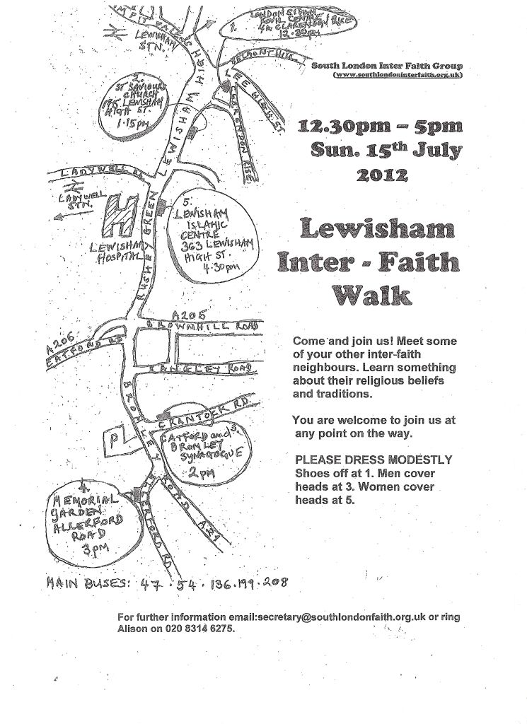
2012 Olympic Inter Faith Walks (Lewisham)

In celebration of the Olympics and the rich diversity within our local communities, the South London Inter Faith Group have co-ordinated a series of multi-faith walk routes within south London boroughs during the weekend of 14th and 15th July 2012

This year the Lewisham Walk will take place on Sunday 15th July. Details of the route include

12.15pm: Meet at the London Sivan Kovil Temple, 4a Clarendon Rise. SE13 5ES (020 8318 9844) There will be a tour of the temple and a Q and A session followed by refreshments. An opportunity to visit this recently refurbished temple.
We will then walk from the Temple along Lewisham High Street to arrive at
1.15pm: at St Saviours Roman Catholic Church, 175 Lewisham High Street, SE13 6AA (020 8852 2490) This will be a meeting point for new walkers and then a short visit inside this gem of a church.
There will be a short bus ride to
2pm: the Catford and Bromley (Orthodox) Synagogue, Crantock Road, SE6. There will be a short talk and a Q&A, followed by refreshments at this small and beautiful synagogue.
3pm: Garden of Remembrance Interfaith Service at the Memorial Gardens, Allerford Road, Bellingham SE6. This annual event is organised by the British Legion will involve a short march starting at the Synagogue, then along the Bromley Road to the Memorial Gardens in Allerford Road. Walkers are welcome to join the service if they wish.
4.30pm Visit to the Lewisham Islamic Centre, 365 Lewisham High Street, SE13 6NZ. An opportunity to make a visit to this established centre.

The walk is open to people of all faiths and none so this will be a fantastic opportunity to visit places of worship and learn more about each other as neighbours. Please note people are required to observe the following dress codes
- Please dress modestly and remain covered
- Kippahs will be available at the Catford and Bromley Synagogue.
- People are kindly asked to remove their shoes when visiting the London Sivan Kovil Temple.
- Women to cover their heads at the Lewisham Islamic Centre

Please help us make this occasion a success and encourage friends and family to come along!

For updates and further information see the South London Inter Faith Group website www.southlondoninterfaith.org.uk or if you would like to attend please contact the co-ordinator Alison Licorish on 020 8314 6275.

