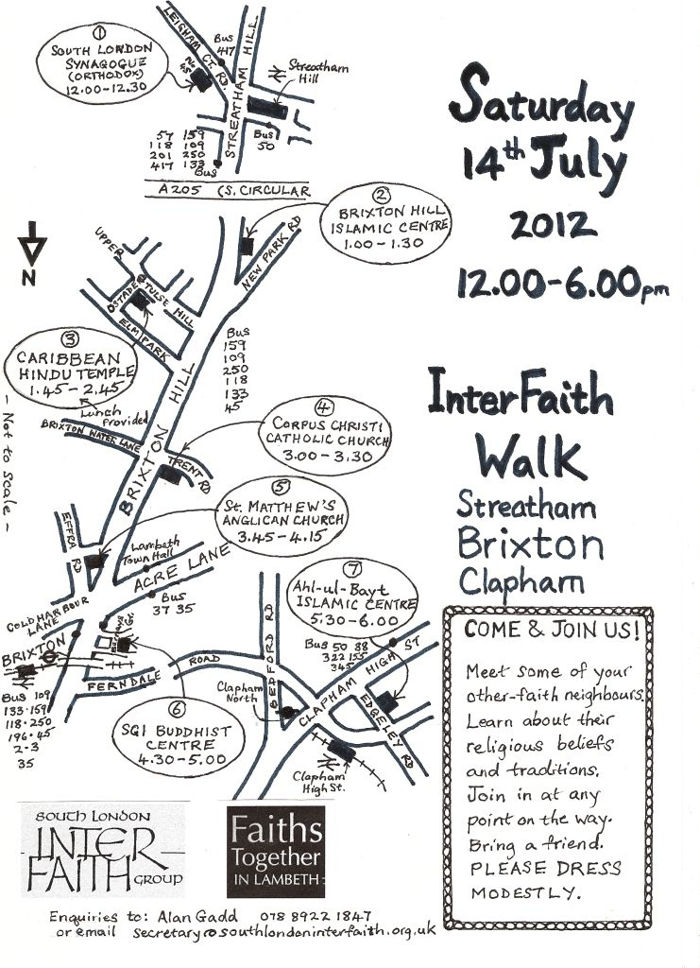


Faiths Together in Lambeth, 24 Holmewood Gardens, London SW2 3RS

ftil@hotmail.co.uk 07889 221 847

2012 Inter Faith Walks
Saturday 14th July 12noon – 6pm
Streatham Hill - Brixton - Clapham High Street
Please dress modestly and be ready to remove your shoes. Lunch provided.

1. South London Synagogue (Orthodox) 12.00 – 12.30pm
45 Leigham Court Road SW16 2NF

2. Brixton Hill Islamic Centre 1.00pm – 1.30pm
226/228 Brixton Hill SW2 1HE

3. Caribbean Hindu Temple 1.45pm – 2.45pm
16 Ostade Road SW2 2BA [Lunch provided here.]

4. Corpus Christi Church 3.00pm – 3.30pm
11 Trent Rd SW2 5BJ

5. St Matthew’s Church 3.45pm – 4.15pm
Brixton Hill SW2 1JF

6. SGI Buddhist Centre 4.30pm – 5.00pm
1 Bernays Grove SW9 8DF

7. Ahl-ul-Bayt Islamic Centre 5.30pm - 6.00pm
11 – 13 Edgeley Road SW4 6EH

This Walk is one of 12 coordinated by South London Inter Faith Group during the weekend of 14th/15th July, just before the London Olympics. See www.southlondoninterfaith.org.uk/2012-inter-faith-walks/.

The overall aim is to use this time when the global spotlight is on London to celebrate the multi faith character of London and to demonstrate the inter faith collaboration that is taking place.

