Greenwich  Inter Faith Walk 2012  Saturday 14th July  11 a.m. to 5.30 p.m.  One of many inter faith walks all across South London on a single weekend in this Olympic year, to celebrate the multi faith character of London and the ways in which people of different faiths work together. | Join in at any point on the way  Please dress modestly  All cover heads at the Sikh Gurdwara, and women cover heads and wear trousers or long skirts at the Greenwich Islamic Centre  You would be welcome to bring a picnic for lunch to eat on the way. Langar (community food) will be served at the Sikh Gurdwara in Mason’s Hill at 5 p.m.

Timetable (subjects of presentations and question and answer sessions in square brackets [ ]):
11 a.m. Greenwich Islamic Centre, Plumstead Road [Islam] (the Mayor and Mayoress of the Royal Borough of Greenwich will join us here)
12.30. St. Patrick’s Church, Conway Road/Hector Street [the Christian faith; the Philippino community; Buddhism and the Chinese community]
14.45 Hindu Temple, Bannockburn Road [the Hindu faith, and the Gurkha community]
16.15 Sikh Temple, Masons Hill [the Sikh faith]. The visit finishes with Guru Ka Langar (Community Food served free) at 17.00
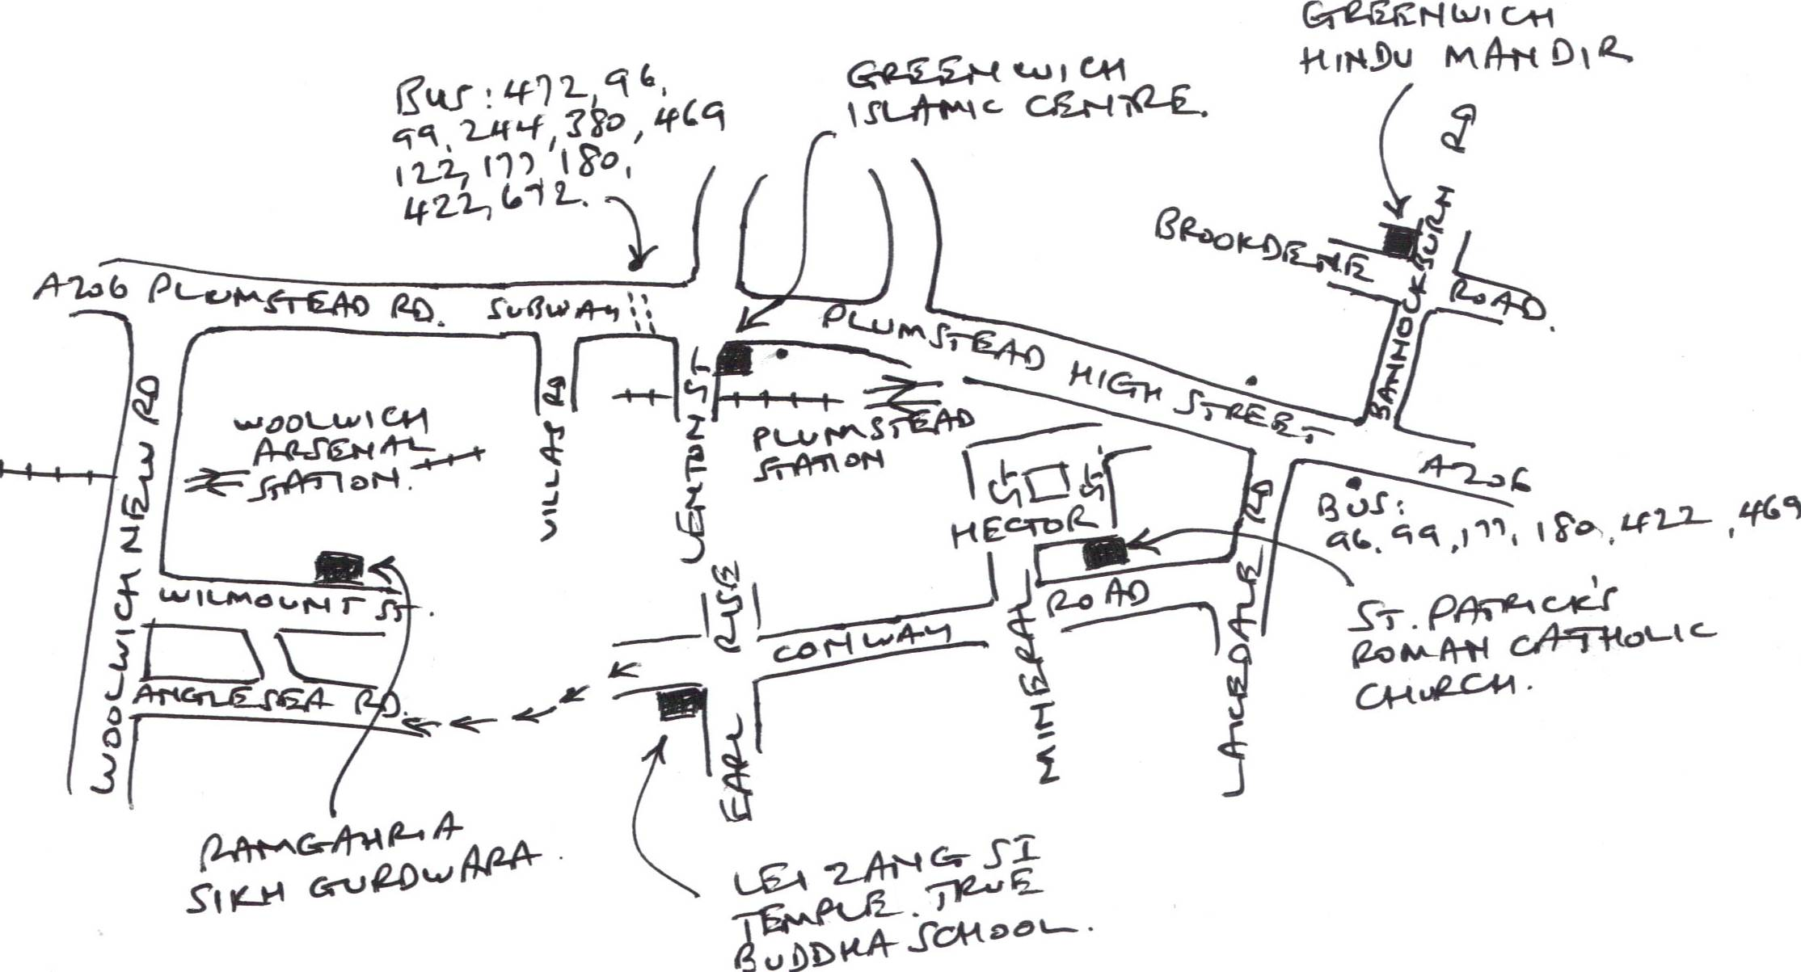
We very much hope that you will be able to join us
The Rev’d Malcolm Torry, Secretary, Greenwich Faith Community Leaders
Balbir Singh Bakhshi, walk organiser
Further information from: Balbir Singh Bakhshi, 07709 658893

LONDON INTER FAITH WALKS IN 2012
Saturday and Sunday, 14th and 15th July
In view of the ensuing London 2012 Olympic Games being held in London in July 2012, the South London Inter Faith Group is co-ordinating a series of multi faith walks in various parts of South London. The walks are to show the faith communities’ solidarity with each other, and to welcome the Olympic Games.
The walks are all taking place during the weekend of the 14th and 15th July 2012. Local groups have chosen the Saturday or the Sunday, or both, depending on local factors.
The aim is to use this time when the global spotlight is on London to celebrate the multi faith character of London and to demonstrate the inter faith collaboration that is taking place.

The Greenwich Faith Community Leaders have organised this Greenwich walk on the 14th July
In line with other Boroughs, the Greenwich Faith Community Leaders have organised this walk on 14th July 2012 in the Royal Borough of Greenwich. The walk will start from the Islamic Centre, Woolwich at 11.00 hours and finish by 17.30 hrs at the Sikh Temple, Mason’s Hill, where the Langar (free community food) would be served.
Among other things, the main objective of all such walks is to visit various Places of Worship of different faiths, to show the world that in London, different faith communities, believing in different faiths, can live together and value each others’ faiths.
The Mayor and Mayoress of the Royal Borough of Greenwich have very kindly accepted the invitation to take part and will be with the walkers from 11.00 hrs to 12.00 hrs.

Balbir Singh Bakhshi The Rev’d Malcolm Torry, Secretary,
Walk Organiser Greenwich Faith Community Leaders
Further information from: Balbir Singh Bakhshi, 07709 658893

