CROYDON INTER FAITH WALK SATURDAY 14th July 2012

Details of route, locations of places being visited and timings are as follows. See next page for map.

Location | Arrive | Depart | Venue | Details
1 | 10.00am | 10.30 | Croydon Faith Education Resources, CFER  rear of Oasis Academy & Ashburton Library, Shirley Road,  Croydon CR9 7AL | Multi faith resource centre (charity) supporting schools, community and faith groups in Croydon  www.cferinfo.org.uk
2 | 11.00 | 11.30 | St Mark’s Church  Albert Road,  London SE25 4JE | Anglican Church with an interesting Baptistry
3. | 11.40 | 12.40 | South Norwood Islamic Community Centre  1-3 Clifford Road,  London SE25 5JJ | A Sufi Mosque and community centre
4. | 1.00pm | 2.15 | Sri Sri Radha Krishna Culture Centre  42 Enmore Road,  London SE25 5NG | Krishna Hindu Temple and community centre.  Vegetarian lunch is being provided.
5. | 3.00 | 3.50 | Nanak Community Centre  St James Road,  Croydon CR0 2RJ | Sikh Gurdwara and community centre
6. | 4.00 | 4.45 | Ahmadiyya Muslim Association, Baitus Subhan  59 St James’ Road,  Croydon CR0 2US | Ahmadiyya Mosque and community centre

Les Kemp, Faiths Together in Croydon 9/06/2012 ak.ljk@blueyonder.co.uk

CROYDON INTER FAITH WALK
SATURDAY 14th July 2012
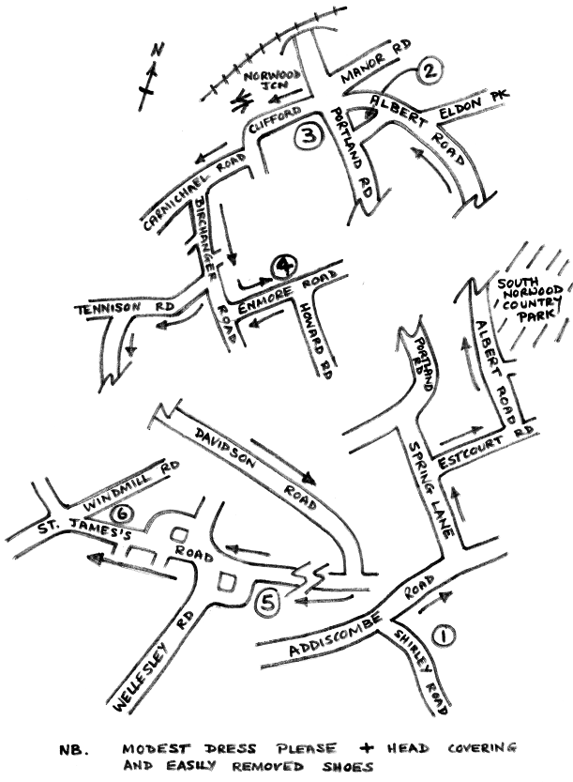

Enquiries/Bookings to Sarah Taylor Tel: 020 8253 7080
Email: sarah.taylor@cvalive.org.uk

